Teaching Materials

Introduction
MIPSfpga provides the RTL source code of the MIPS microAptiv UP core for implementation on an FPGA, together with teaching materials. The MIPS microAptiv UP core is a member of the same microcontroller family found in many embedded devices, including the popular PIC32MZ microcontroller from Microchip and Samsung’s new Artik1.
The teaching materials will show you how to use this core as part of a Computer Architecture course, paving the way for your students to explore how a commercial pipelined processor core works inside and to use this core in their projects, in effect creating their own SoC designs.
With its long heritage and excellent documentation, MIPS is the preferred choice of RISC architecture for many teachers around the world. But in the past, to demonstrate key concepts, teachers had to settle for creating partial ‘MIPS-like’ cores or using unofficial copies of dubious heritage. Not now! MIPSfpga is the real ‘industrial’ RTL, non-obfuscated, and available freely for academic use.

Structure
The MIPSfpga teaching materials consist of three parts:
The Getting Started Package contains a detailed guide that begins with a brief introduction to the MIPSfpga core included in the package. It gives a brief overview of how to setup the core for simulation or putting it on to an FPGA, as well as programming the processor. Guides on software installation are also given, along with detailed references about the core and its ISA – Instruction Set Architecture. All users need this package first.
MIPSfpga Fundamentals. In here you will find slides with accompanying lab scripts, illustrated using the Nexys 4 DDR and DE2-115 platforms. With this you will be taken from building the core, to programming in both c and assembly, with exercises to complete along the way. You then move on to adding a range of peripherals to the core to enable a greater level of interaction. The final example takes you through porting MIPSfpga to other FPGA boards such as Basys 3.
MIPSfpga SOC. The Advanced package enables you to run Buildroot Linux on MIPSfpga specifically using the Nexys4 DDR platform. The microAptiv core is packaged as an IP block usable by Vivado IP Integrator. As a result, AXI based IP blocks from Xilinx can easily be interfaced with the MIPS core. These are used to create an example SoC, such as a design with a UART and Ethernet, running under Linux, on MIPSfpga. A custom AXI GPIO block along with an example Linux driver is also provided. There is extensive documentation included. Collectively these provide an excellent basis for a SoC course that is highly relevant to the needs of the chip design industry, although the level of complexity makes this a postgrad class. PhD students and Postdocs will also find this material very useful for advanced projects.

Target Courses & Projects (Education Level)
- Digital Design & Microarchitectures (BSc)
- Computer Architecture, Advanced Computer Architecture (BSc, MSc)
- SoC design (MSc)
- Design Verification (MSc)
- Embedded Systems projects (BSc, MSc)
- Processor Architecture: modifications, enhancements, optimisation…(MSc, PhD)

The Authors
The course materials were developed by David Harris and Sarah Harris, co-authors of the popular textbook Digital Design and Computer Architecture which provides a uniquely relevant accompaniment to MIPSfpga.

Complementary Materials
- The textbook ‘Computer Organisation and Design’ by David Patterson and John L. Hennessy remains the ‘bible’ for these activities, and provides further depth to Harris & Harris in a MIPSfpga-based course.
Other relevant textbooks are referenced here: http://community.imgtec.com/university/resources/books/?subject=mips-architecture
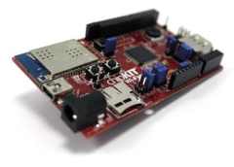
Access the microAptiv core in silicon through boards such as Digilent’s ‘WiFire’ incorporating Microchip’s PIC32MZ MCU.
- Videos of the workshop given by Sarah Harris and Parimal Patel of Xilinx will be posted online in September 2015 here: http://community.imgtec.com/university/video-gallery/

Required Tools
Hardware
- Host PC: Windows 64 bit
- Digilent Basys 3 or Nexys 4 DDR, with Xilinx Artix FPGA
- Porting to other boards has been shown: Zed board, Nexys 3, Nexys 4 (not DDR), DE0-CV and SP605
- JTAG Probe: SEEED Studio MIPS Bus Blaster including 14 to 6 pin adaptor (for Digilent boards)

Software
- Codescape MIPS SDK Essentials (included with Getting Started Package)
- Vivado (Xilinx) Web Pack edition
- Open OCD (included with Getting Started Package)
- Mentor Graphics ModelSim (Student or Full editions) or Xilinx Xsim

Core Structure
The core is approximately 40K gates.
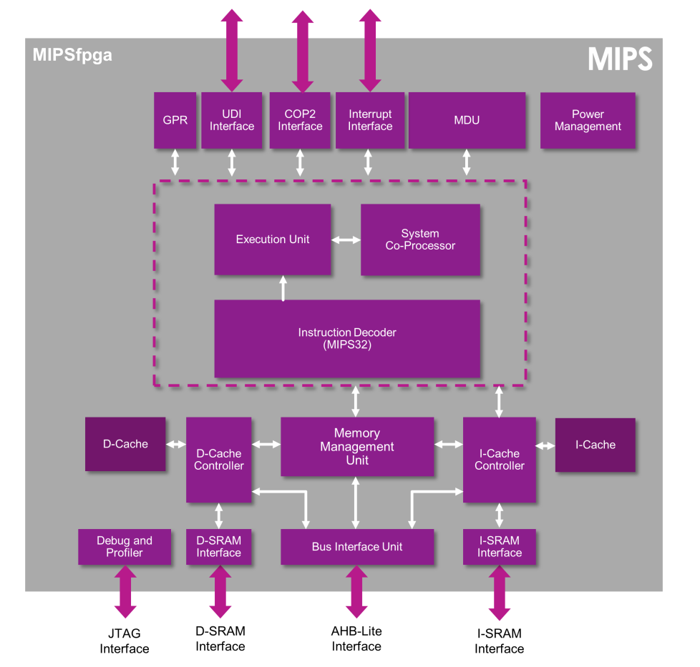

Languages available for Getting Started & Fundamentals
- English
- Simplified Chinese
- Japanese
- Russian
- Spanish

Support
- The MIPS insider forum here has a thread specifically for technical questions about MIPSfpga
- For curriculum and other discussions, there is the IUP (Imagination University Programme) forum here
Partners
We have worked closely with Xilinx and Digilent who have given wonderful support to this large and complex project.

Details on their University Programmes are here:
http://www.xilinx.com/support/university.html
https://learn.digilentinc.com/list

User Licenses
- For the MIPS core:
The agreement is part of the Getting Started Package download process, and acceptance is required before the download request can be submitted.
The End User Licence Agreement (EULA) allows the use of the MIPS core on FPGA platforms for the academic purposes of teaching, student projects and research. It allows teachers to distribute the core to students in classes, and it allows for the core to be modified. It does not allow the core to be put into silicon. Furthermore, if the core is modified and the user wishes to patent these modifications, the licence requires that this is negotiated with Imagination first.
The EULA is written in plain English, and a copy of the EULA is part of the Getting Started package for future reference.
- For the Teaching Materials:
The agreement is part of the Fundamentals and Advanced download process.
The End User Licence Agreement (EULA) explains that the materials are for Educational and Non-Commercial use, which means that companies or trainers who wish to use the materials for paid-for training, must seek Imagination’s prior permission. Distribution of the materials to your Students is expressly allowed. The agreement allows extracts of the material to be used in derived teaching materials as long as Imagination’s copyright is acknowledged, but publication in textbooks needs prior permission (which is usually given). No warranty is provided as to the effectiveness of the materials. The EULA is written in plain English, and a copy of the EULA is included in the materials package for future reference.

Plans
We are always pleased to hear about your needs for Teaching Materials. Our focus over the next year will be on workshops to promote use of MIPSfpga, releasing the Advanced package, debugging the existing materials, and listening to your feedback through the MIPSfpga thread on the forums. In addition, we are working on an ‘MPW’ route for researchers who would like to implement MIPS in silicon.
What we do after that will be determined primarily by you!

Press Release & Blogs
Free and Open Access to a Modern MIPS CPU
http://imgtec.com/news/press-release/imagination-revolutionizes-cpu-architecture-education-with-free-and-open-access-to-a-modern-mips-cpu-3/

MIPSfpga programme opens up the MIPS architecture to universities worldwide
http://blog.imgtec.com/mips-processors/mipsfpga-opens-up-the-mips-architecture-to-universities-worldwide

How to join the IUP and access these materials
- Click ‘Register’ or ’Join IUP’ on the landing page: www.imgtec.com/university
- Complete the first section: ‘the Community Registration’
- Tick the box marked ‘Join Imagination University Programme’ and completes the additional information
- A verification email will be sent to your inbox for activation.
(Please also check your spam mailbox because occasionally the mail will got filtered)
- To download teaching materials, visit the IUP page -Resources http://community.imgtec.com/university/resources/
- Request the package(s) you want, accept the Licence Agreement, and give some details about how you plan to use the materials.
- We then receive a request to approve the download, and normally action this within 48 hours. Once approved, you will receive an e-mail saying you can now make the download.
NOTE: Requests may be rejected for the following reasons
- The registration details are incomplete
- There are few or no details of intended use
- The requester appears to be a commercial company or a competitor
Please feel free circulate this information to anyone who might be interested and keep an eye on our webpages for further information such as workshops and updated packages.

Lab 1
Setting up a Vivado Project for MIPSfpga

MIPSfpga Lab 1: Setting up a Vivado Project

Introduction
This is the first in a series of laboratory exercises acquainting you with system-on-chip design using Imagination's MIPSfpga platform. In this lab you will learn to set up a Vivado project for simulating, synthesizing, and downloading the MIPSfpga system onto Digilent's Nexys4 DDR FPGA board. As you make changes to the MIPSfpga system in the future, you can follow these steps to compile, simulate, synthesize, download, and test your changes.

The instructions in this lab use Vivado 2015.1. Instructions for later versions of Vivado are similar, if not exactly the same.

Setting up a Vivado Project
In this section we walk through the steps of (1) creating a project for the MIPSfpga system, (2) simulating the project, (3) compiling the project, and (4) downloading the MIPSfpga system onto the Nexys4 DDR board.
Before setting up the Vivado project, make a copy of the MIPSfpga system by copying the rtl_up folder in the MIPSfpga directory (provided with the MIPSfpga Getting Started materials) to MIPSfpga_Fundamentals\rtl_up.
The Verilog files in the MIPSfpga_Fundamentals\rtl_up directory describe the MIPSfpga system and are the design source files for the Vivado project you are about to create. In later MIPSfpga Fundamentals labs, you will extend the functionality of the MIPSfpga system by both modifying and adding Verilog files to the MIPSfpga_Fundamentals\rtl_up folder.

Step 1. Create Vivado project
Start Vivado. Open a new project by choosing File → New Project (see Figure 1).

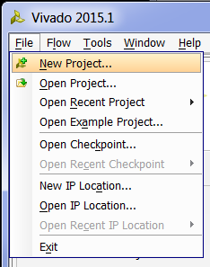
Figure 1. Create new Vivado project

Click Next. Browse to the MIPSfpga_Fundamentals\Xilinx\Lab01_Vivado folder and place the new project, Project1, in that folder, as shown in Figure 2. Click the Create Project subdirectory box and click next, as shown below.

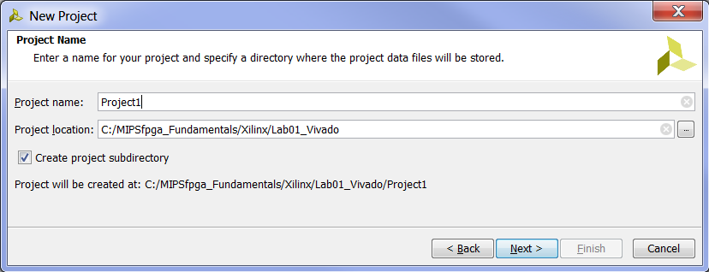
Figure 2. Create Vivado project directory

In the next window, leave RTL Project selected and click Next.
Now in the Add Sources window, click on the green plus sign and Add Files... Browse to the MIPSfpga_Fundamentals\rtl_up directory. Select all of the files (ctrl-a or click, shift-click), as shown in Figure 3, and click OK.

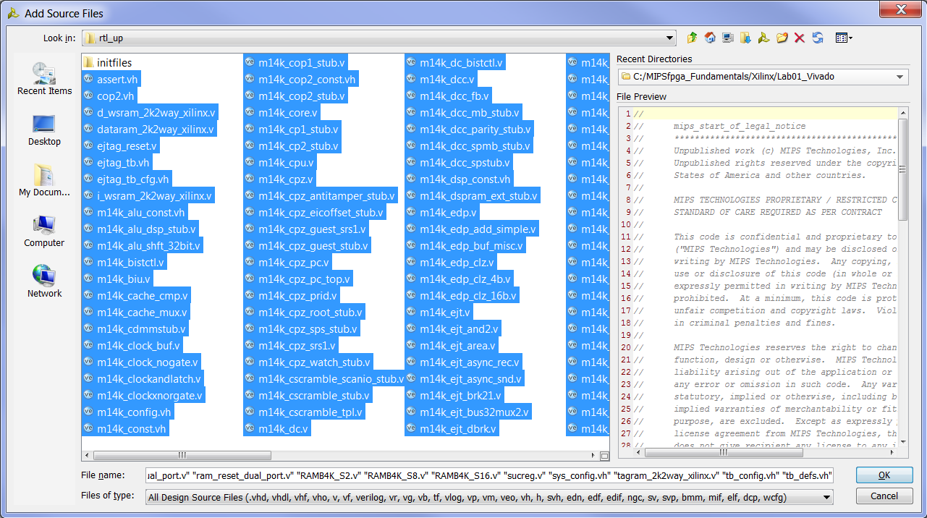
Figure 3. Adding Verilog files to project

The project should refer to the Verilog (.v) and Verilog header (.vh) files located in the MIPSfpga_Fundamentals\rtl_up directory – you do not want to make a local copy of the files in the Vivado project. So, in the next window, make sure the Copy the sources into Project box is not selected (see Figure 4) and click Next.

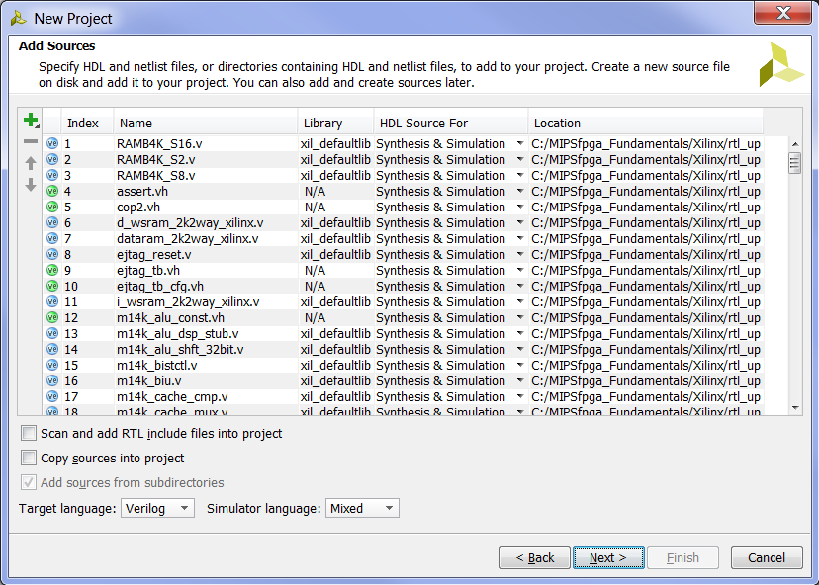
Figure 4. Adding Sources – do not copy sources into project

You will not add any IP, so click Next in the Add Existing IP (optional) window.
In the Add Constraints (optional) window, click on and Add Files... Browse to the MIPSfpga_Fundamentals\Xilinx\Lab01_Vivado directory. Select mipsfpga_nexys4_ddr.xdc and click OK (see Figure 5). This constraints file maps the Verilog signals to pins on the FPGA and describes timing constraints.

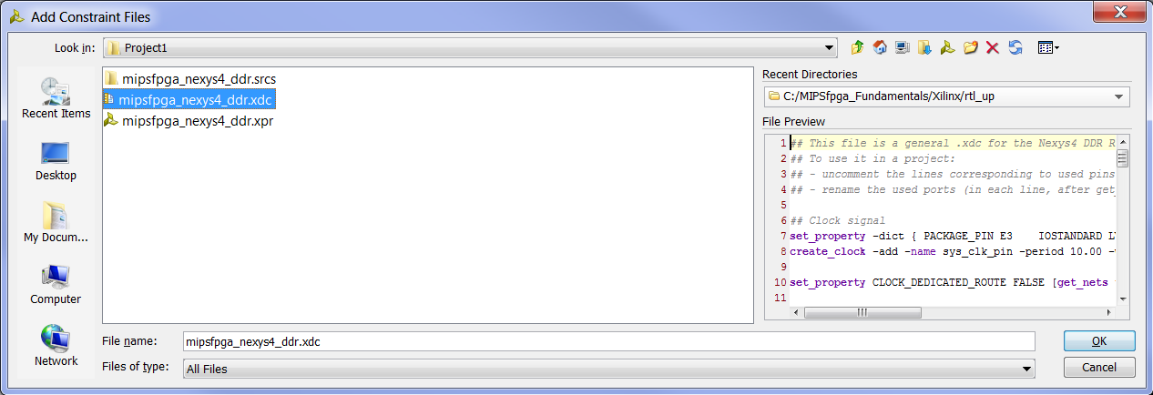
Figure 5. Add Xilinx Design Constraints (.xdc) file to Vivado project

Click on the Copy constraints files into project box (see Figure 6) and click Next.

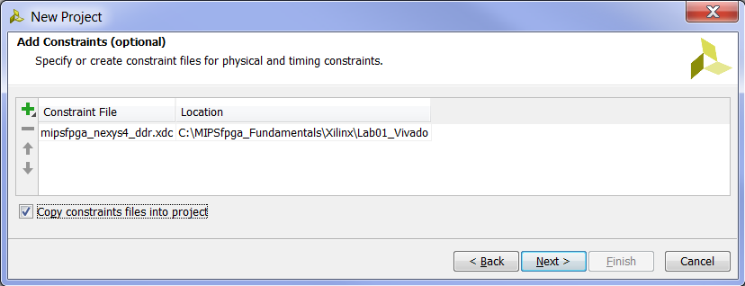
Figure 6. Copy .xdc file into Vivado project

Now you will choose the Artix-7 FPGA that is on the Nexys4 DDR board as the target. Type (or copy-paste) the following into the search box: xc7a100tcsg324-1, as shown in Figure 7. Select the part, as shown, and click Next.

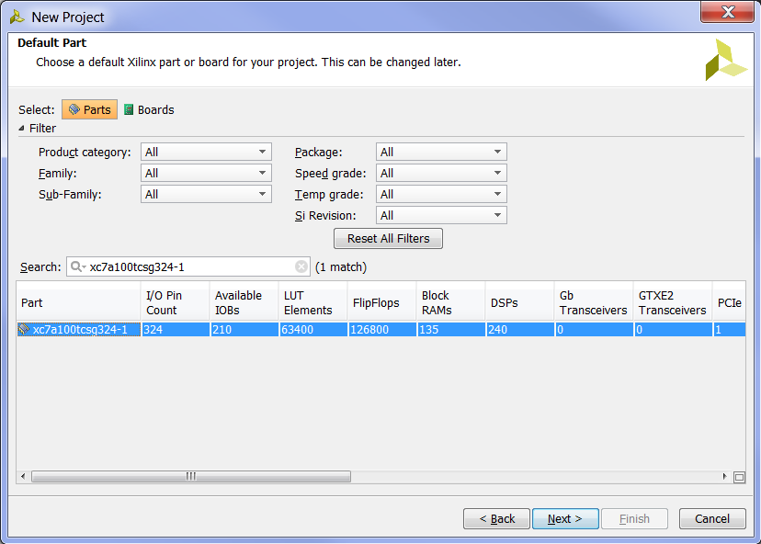
Figure 7. Selecting the Artix-7 FPGA

"xc7a" indicates that it is an Artix-7 FPGA. "100t" says that it has about 100k Logic Cells. "csg324" indicates a "chip scale ball grid array (BGA)" package with 324 pins, and "-1" is the speed grade.

Now click Finish in the New Project Summary window (see Figure 8).

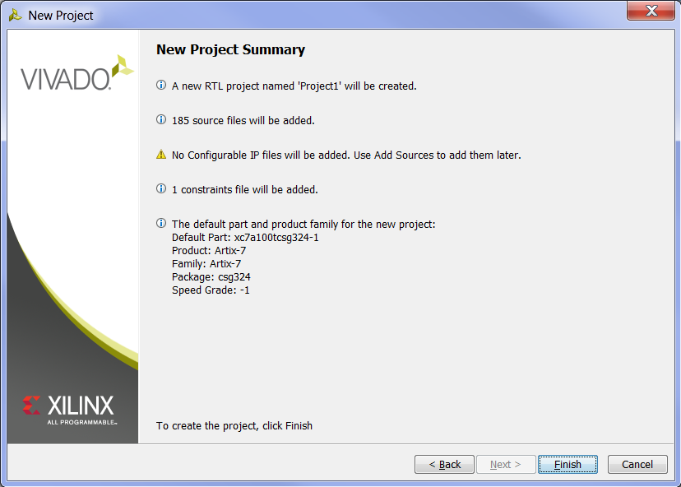
Figure 8. New Project Summary window

After the project initializes, go to the Project Manager window, right-click on mipsfpga_nexys4_ddr, and select Set as Top in the pull-down menu, as shown in Figure 9. This will set that module as the top-level module to synthesize, compile, and download to the Nexys4 DDR board.

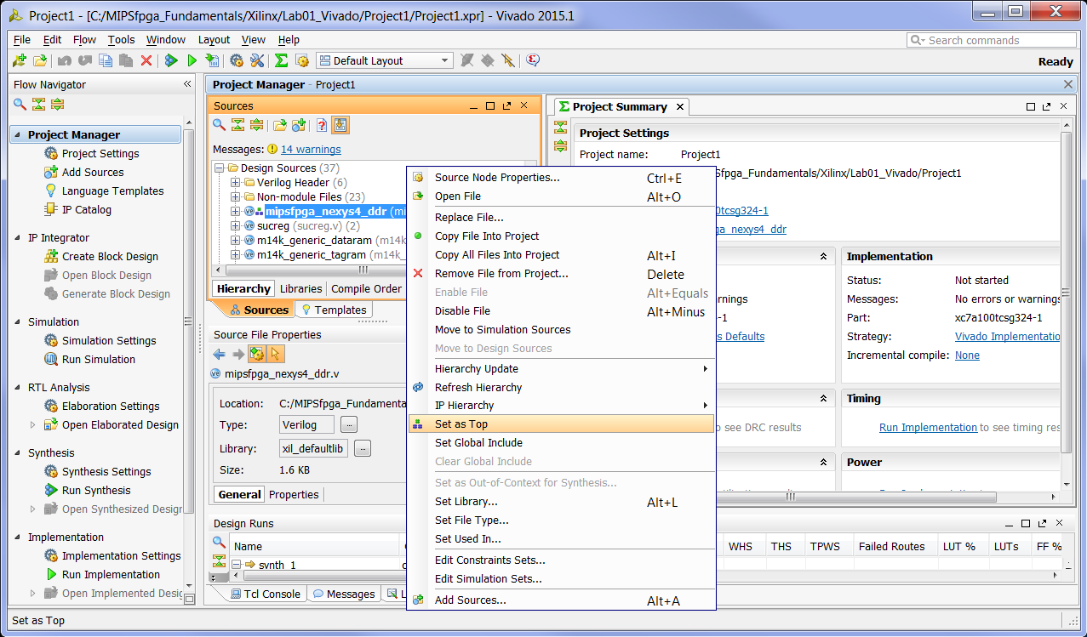
Figure 9. Setting the top-level module for synthesis, implementation, and bitstream generation

The last step of creating the project is to add a PLL that reduces the on-board 100 MHz clock to 50 MHz to meet timing constraints. To create the PLL, click on IP Catalog under Project Manager in the Flow Navigator, as shown in Figure 10.

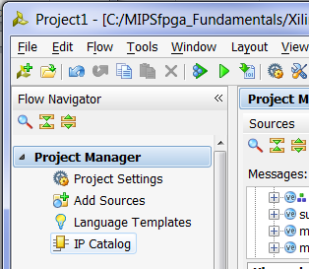
Figure 10. IP Catalog

Now, in the IP Catalog tab of the Project Manager pane, expand FPGA Features and Design, and then expand Clocking. Double-click on Clocking Wizard, as shown in Figure 11.

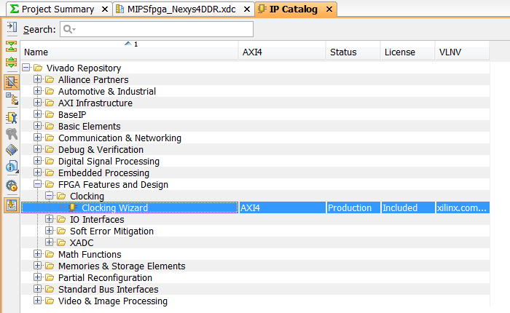
Figure 11. Clocking Wizard

The Clocking Wizard window will pop up, as shown in Figure 12. Select PLL, as shown in Figure 12. Leave the Input Clock information as the default (100 MHz).
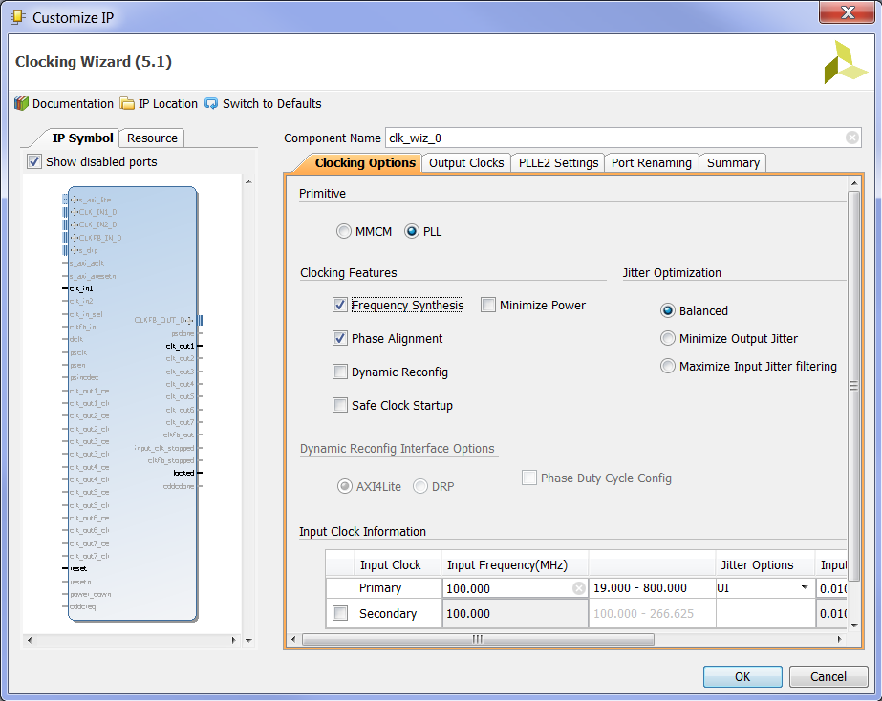
Figure 12. Clocking Wizard window

Now click on the Output Clocks tab, and type in 50 as the output frequency in the Output Freq (MHz) Requested box for clk_out1, as shown in Figure 13.

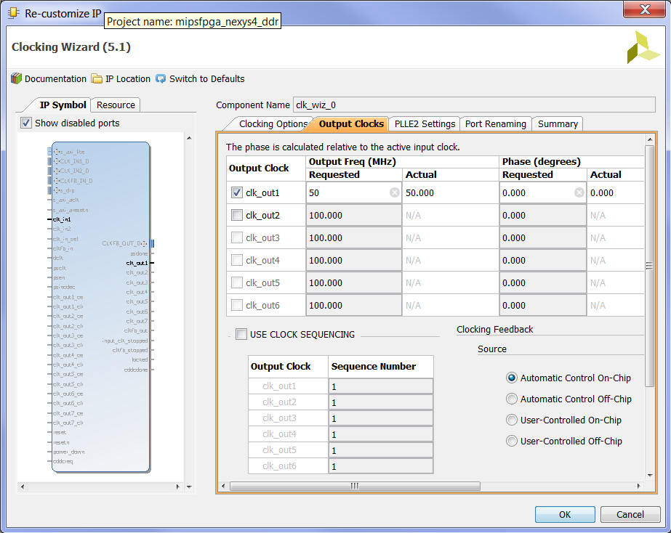
Figure 13. Select output clock frequency

Scroll down in the same tab (Output Clocks) and deselect reset and locked, as shown in Figure 14. Then click OK to complete the creation of the PLL.

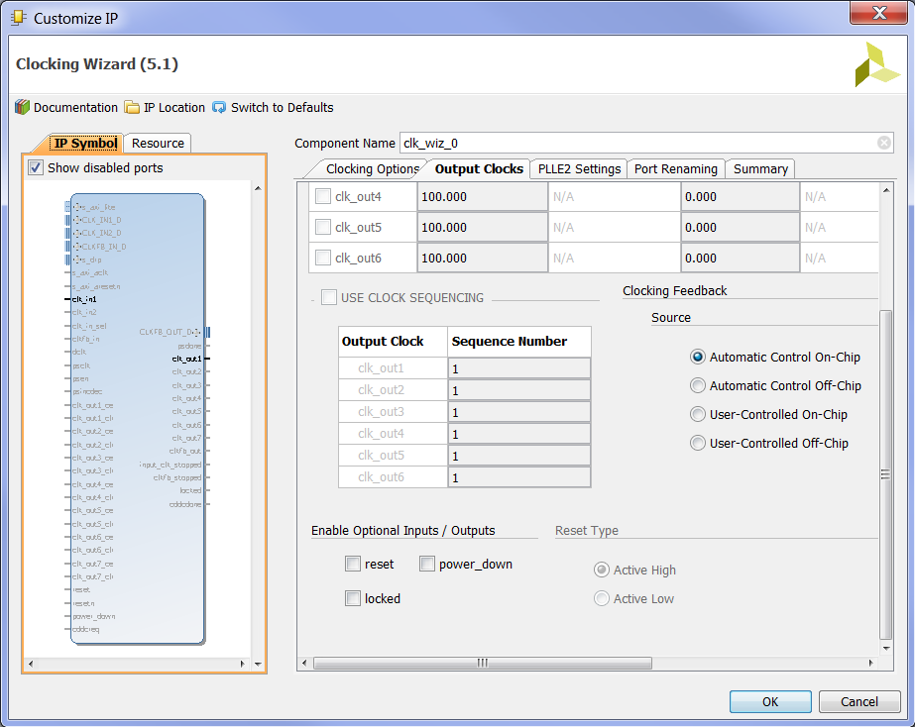
Figure 14. Deselect reset and locked

A pop-up window will prompt you to "Generate Output Products", as shown in Figure 15. Click Generate.

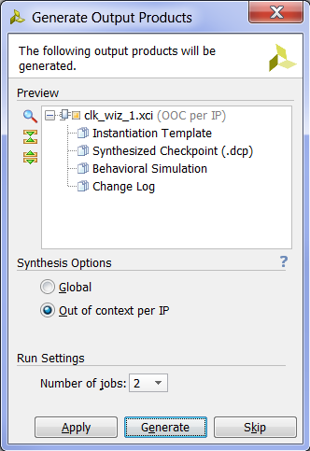
Figure 15. Generate PLL

A window will pop up that says "Out-of-context module run was launched for generating output products," as shown in Figure 16. Click OK.
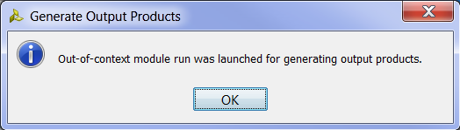
Figure 16. Out-of-context generation of PLL

Step 2. Simulating MIPSfpga
Now you are ready to simulate the MIPSfpga system. You will use Vivado's built-in simulator called XSIM. We already added the testbench.v file when we created the project, and now we will make it the top-level module for simulation. In the Project Manager panel, scroll down to Simulation Sources and expand it and the sim_1 folder.

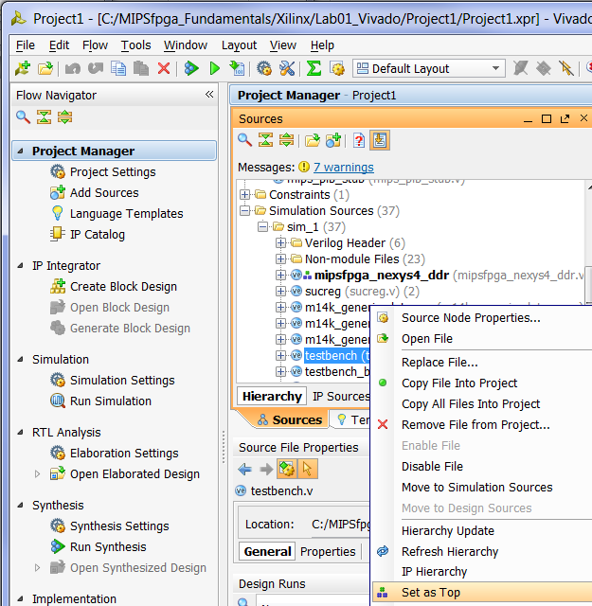
Figure 17. Setting the top-level module for simulation

Right-click on testbench.v and set it as the top-level module for simulation, as shown in Figure 17. Notice that the testbench entry is now bold.

Click on Add Sources in the Flow Navigator window on the left, select Add or create simulation sources option, and then click Next. Click on and Add Files…, select All Files in the Files of type filter, browse to the ram_reset_init.txt file in MIPSfpga_Fundamentals\rtl_up\initfiles\1_IncrementLEDs, select it, and click OK. Leave the Copy sources into project box unselected, but leave the Include all design sources for simulation box checked, as shown in Figure 18. Then click Finish.

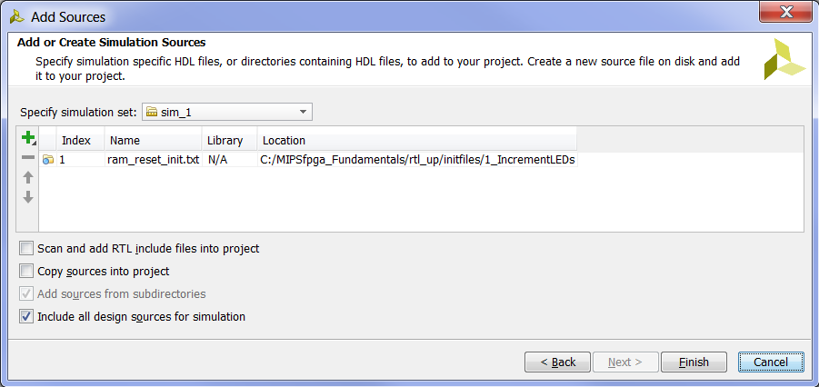
Figure 18. Adding simulation source

The text file contains the instructions that will be loaded into MIPSfpga's memory. As you recall from the MIPSfpga Getting Started Guide, this program, as shown in Figure 19 for your convenience, writes incremented values to memory address 0xbf800000. Also recall from the MIPSfpga Getting Started Guide that the LEDs on the Nexys4 DDR board are mapped to memory address 0xbf800000. So the program writes incremented values to the LEDs.

// C code  unsigned int val = 1;  volatile unsigned int* dest;  dest = 0xbf800000;  while (1) {  *dest = val;  val = val + 1;  } | # MIPS assembly code  # $9 = val, $8 = mem address 0xbf800000  addiu $9, $0, 1 # val = 1  lui $8, 0xbf80 # $8=0xbf800000  L1: sw $9, 0($8) # mem[0xbf800000] = val  addiu $9, $9, 1 # val = val+1  beqz $0, L1 # branch to L1  nop # branch delay slot
Figure 19. IncrementLEDs program

The equivalent machine code for the IncrementLEDs program is given in Figure 20.

Machine Code Instruction Address Assembly Code
24090001 // bfc00000: addiu $9, $0, 1 # val = 1
3c08bf80 // bfc00004: lui $8, 0xbf80 # $8=0xbf800000
ad090000 // bfc00008: L1: sw $9, 0($8) # mem[0xbf800000] = val
25290001 // bfc0000c: addiu $9, $9, 1 # val = val+1
1000fffd // bfc00010: beqz $0, L1 # branch to L1
00000000 // bfc00014: nop # branch delay slot
Figure 20. MIPS machine code

Expand the hierarchy under Simulation Sources and observe that ram_reset_init.txt is added in a separate sub-folder called Text and it contains the machine code (see Figure 21). Now you are ready to run the simulation of the MIPSfpga system running that program.

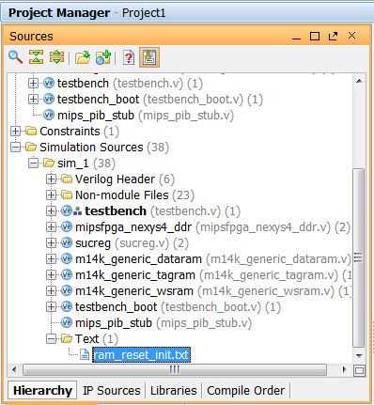
Figure 21. Text file as simulation source

Click on Simulation Settings in the Flow Navigator window on the left, as shown in Figure 22.

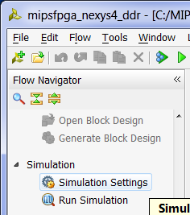
Figure 22. Simulation Settings

The simulation settings window will show up, as shown in Figure 23. Make sure the Generate scripts only is not selected. Click on the Simulation tab and set the simulation run time to 2000 ns. Click OK.

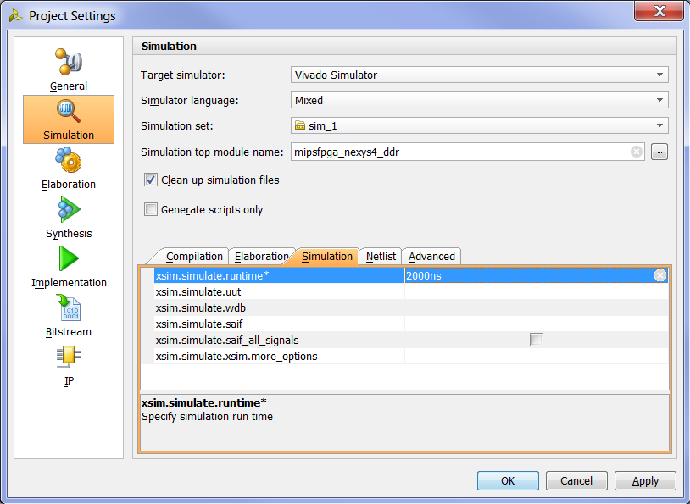
Figure 23. Change simulation run time

Click on Run Simulation → Run behavioral simulation in the Flow Navigator window, as shown in Figure 24.

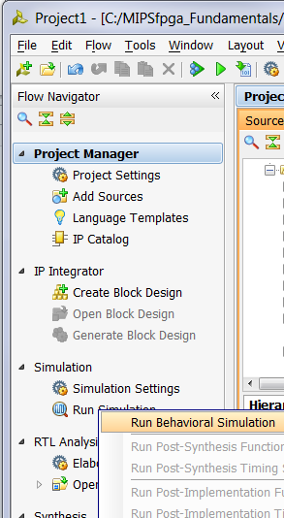
Figure 24. Run simulation

The testbench and lower-level modules will compile, the simulation window will open, and the simulation results will be displayed, as shown in Figure 25. You will see the top-level signals being displayed. Click on the Zoom Fit button ().

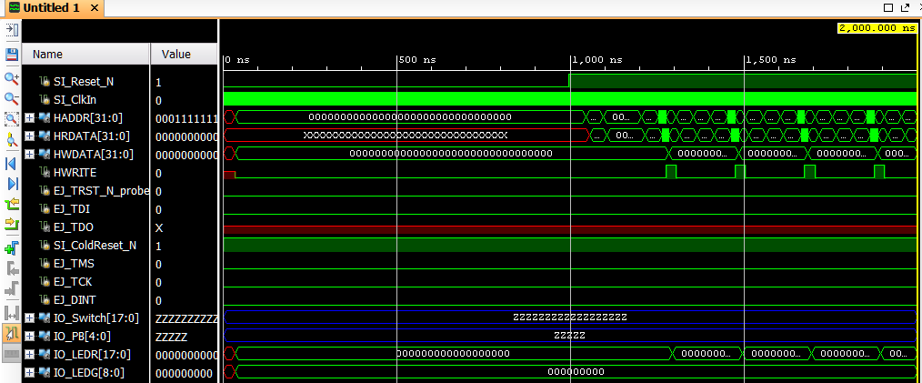
Figure 25. Simulation results showing top-level signals

Select all of the signals in the waveform window and then right-click and select Radix → Hexadecimal. Use shift-click and ctrl-click to select multiple signals at a time.

Delete all of the EJTAG signals and some of the I/O signals: EJ_TRST_N_probe, EJ_TDI, EJ_TDO, SI_ColdReset_N, EJ_TMS, EJ_TCK, EJ_DINT, IO_Switch, IO_PB, and IO_LEDG. Do not delete IO_LEDR. Right-click on a signal (or group of signals) and select Delete. (Or simply select the signals and press the Delete key.) Again, you can also select multiple signals using shift-click and ctrl-click.

The waveform window will now resemble Figure 26.

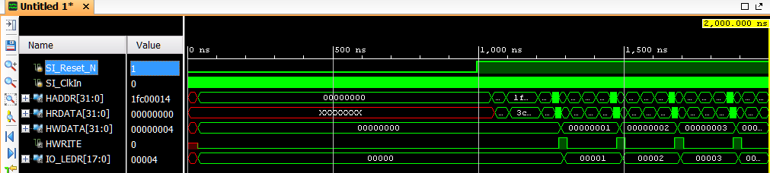
Figure 26. Keeping only the desired top-level signals
You can float the waveform window by clicking on the float button () and then maximize it by clicking on the full size button (left one ). Click on the Zoom Fit button to see the waveform completely. You can also use Zoom In (), Zoom Out (), and Zoom to Cursor () buttons to view a desired section of the waveform.

You can view signals from lower-level modules by adding them to the waveform. For example, as shown in Figure 27, expand the testbench hierarchy to testbench → sys → mipsfpga_ahb → mipsfpga_ahb_ram_reset to see the ram_reset_dual_port entry in the Scopes window. Click on the ram_reset_dual_port entry to see the corresponding signals in the Objects window.
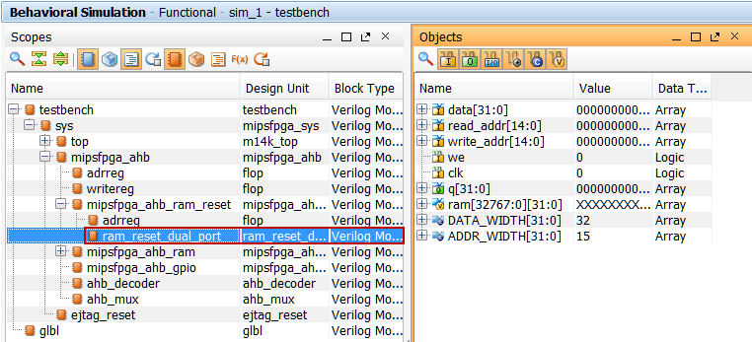
Figure 27. Accessing the signals of lower-level modules

In the waveform window, right-click in the signals area below the last signal, and select New Divider. The New Divider dialog box will appear. Type Reset RAM Memory in the field and press Return.
Select all of the objects in the Objects window, right-click and select Add to Wave Window and observe that the signals are added to the Waveform window. You can change the radix of the added signals to Hexadecimal as before. In the tool buttons bar, change the run time to 4 us . Now click on the Restart button , and then click on the Run for <time> button to reset and run the simulation for 4 us. You will see the output as shown in Figure 28.
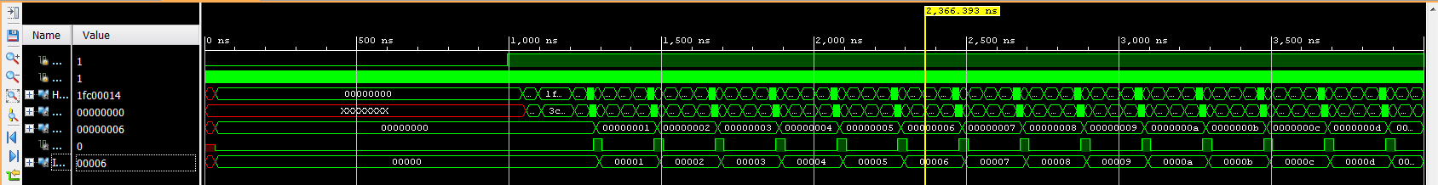
Figure 28. Simulation result showing lower-level module signals

At first the processor is reset: the low-asserted reset signal SI_Reset_N is low. Just after reset (when SI_Reset_N transitions from 0 to 1), you can view the waveform as it fetches each instruction starting with instruction address 0x1fc00000. This address shows up on HADDR and the instruction read from memory appears on the HRDATA bus one cycle later. Recall that virtual address 0xbfc00000 translates to physical address 0x1fc00000. The instructions are executed in sequence until the branch is taken at 0xbfc00010. The code then continuously repeats from 0xbfc00008 – 0xbfc00014. Recall from the MIPSfpga Getting Started Guide, that until the caches are initialized by the boot code, each instruction takes 5 cycles. Also view how incremented values are written on the HWDATA signal as the code executes. HWDATA is the data being written to memory or, in this case, memory-mapped I/O. IO_LEDR displays the incremented value because it is memory-mapped to address 0xbf800000. The IO_LEDR signals are connected to the pins that drive the Nexys4 DDR's LEDs.

After you are finished viewing the waveform, you can close the simulator by selecting File → Close Simuation. A pop-up window will appear asking if you want to save the waveform. You could select Save but for now, click Discard.

Step 3. Compiling MIPSfpga
Now you are ready to compile the MIPSfpga system and create a bitfile that you can download onto the Artix-7 FPGA on the Nexys4 DDR board. Click on the Generate Bitstream button at the top of the window. The bitstream is a file that configures the FPGA to be the MIPSfpga system, as defined by the Verilog files. This file is also referred to as the bitfile.

A window may pop up saying:

There are no implementation results available. OK to launch synthesis and implementation?...

Click Yes. Now wait for synthesis, placement, routing, and bitstream generation to complete. This typically takes around 10-20 minutes, depending on your computer speed.

After the bitstream has been generated, you will see the Bitstream Generation Completed pop-up window, as shown in Figure 29.

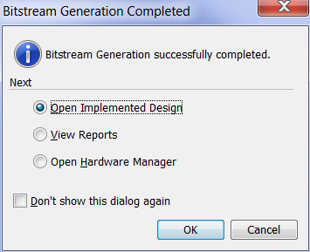
Figure 29. Bitstream Generation Completed pop-up window

Viewing the implemented design is optional, but gives some insight into the timing and layout of the MIPSfpga core. (If you don't want to view it, select Open Hardware Manager and click OK. Then continue with Step 4 below.) To view the implemented design, leave Open Implemented Design selected, and click OK. This will take a few minutes.
Then the Implemented Design window will open, as shown in Figure 30.
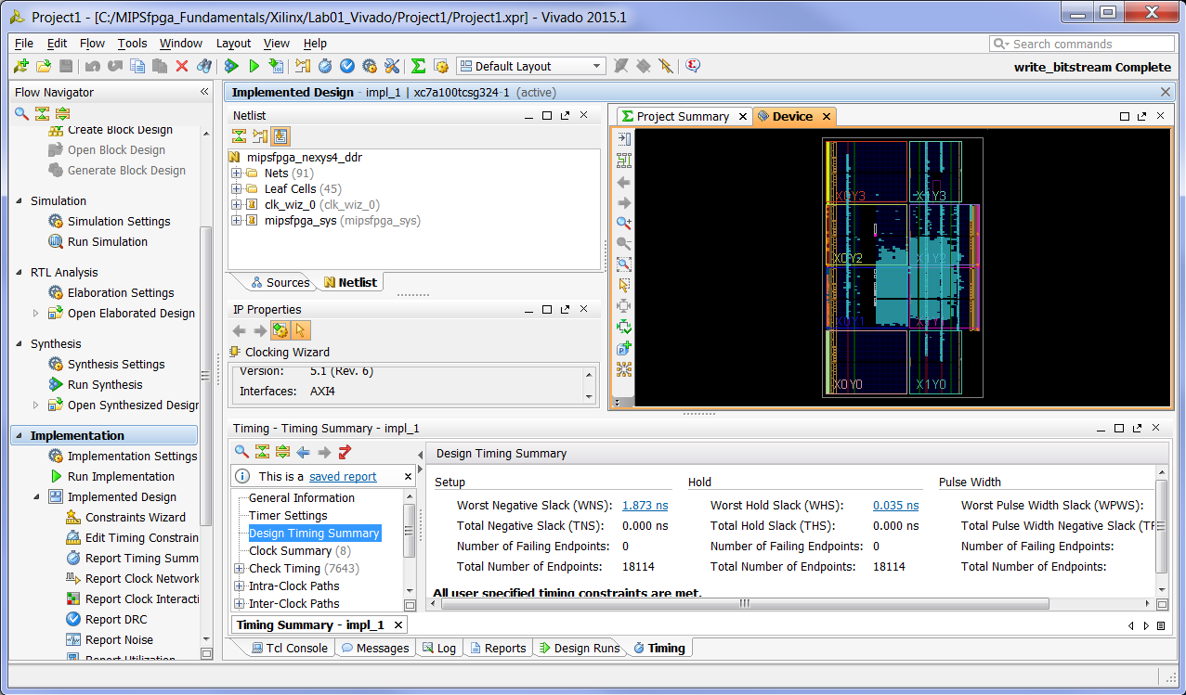
Figure 30. Implemented Design
Notice the Design Timing Summary pane at the bottom. Most importantly, it says that All user specified timing constraints are met. The Worst Negative Slack (WNS) is 1.273 ns and the Worst Hold Slack (WHS) is 0.052 ns, so there are no timing violations. The slack values for your project are likely slightly different. Each time Vivado places and routes the design, a different configuration results.
As you add to or modify the MIPSfpga system in the future, check that the timing constraints are met, and if not, reduce the frequency of the PLL and/or change the timing constraints in the Xilinx Design Constraints (.xdc) file until they are. The WNS will indicate how much the cycle time needs to be increased.
For example, Figure 31 shows a Project Summary page for a design that does not meet timing. Notice the negative values of WNS (shown in red). In this case the cycle time is too short by 4.91 ns, so add that amount (or slightly more) to the cycle time to meet timing. If the frequency of the failing design were 100 MHz (cycle time = 1/100 MHz = 10 ns), the cycle time would need to increase to at least (10 + 4.91) ns ≈ 15 ns (frequency = 1/15 ns ≈ 66 MHz).
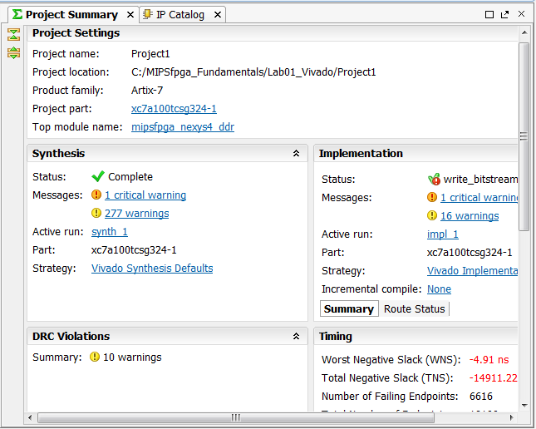
Figure 31. Design that does not meeting timing constraints

Step 4. Downloading MIPSfpga onto Nexys4 DDR FPGA Board
Now you are ready to download the compiled design onto the Nexys4 DDR FPGA board. First, connect and turn on the Nexys4 DDR board. Figure 32 shows the board and highlights the power switch and the USB port. Plug the standard end of the programming cable into your computer and the micro-USB end of the programming cable into the board, at the location labeled "USB Programmer Port" in Figure 32. Now turn the board's power switch ON. If the board is factory configured, the board will run a pre-loaded program that writes to the 7-segment displays with a snake-like pattern that repeats indefinitely. To program the board, it can be in QSPI mode (as shown in Figure 32 with the left-most Mode pins connected by a jumper) or in JTAG mode (with the two middle pins of the Mode selector connected by a jumper).
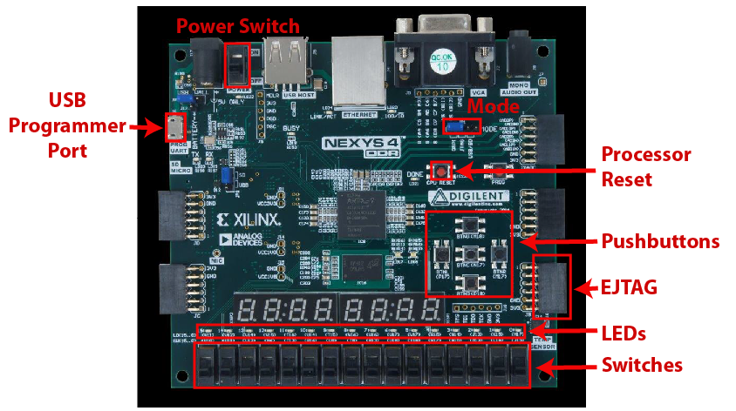
Figure 32. Nexys4 DDR board (photograph © Digilent Inc., 2015)

In the Vivado window, select Flow → Open Hardware Manager, as shown in Figure 33.

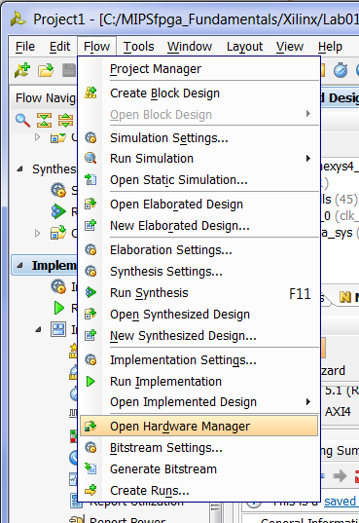
Figure 33. Open Hardware Manager

The Hardware Manager window will open. Now click on Open Target and choose Auto Connect, as shown in Figure 34.

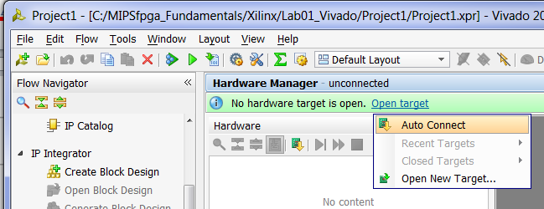
Figure 34. Hardware Manager window, Auto Connect

After you click on Auto Connect, Vivado takes several seconds to connect to the target FPGA on the Nexys4 DDR board. You will see the following warning, that you can ignore:

WARNING: [Labtools 27-3123] The debug hub core was not detected at User Scan Chain 1 or 3. …

If you see the message "No hardware target is open," two causes are most likely:
- You forgot to plug in the Nexys4 DDR board into your computer and/or turn it on.
or
- You need to install/reinstall the driver for the Nexys4 DDR board's USB programmer cable. Refer to instructions in the MIPSfpga Getting Started Guide if you need help reinstalling the driver.

Now click on Program device and select xc7a100t_0, as shown in Figure 35.

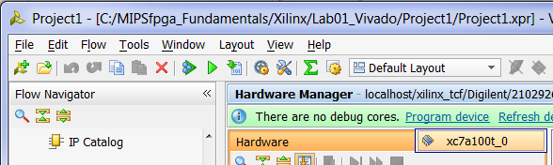
Figure 35. Selecting Program device

The Program Device window will open, as shown in Figure 36. The Bitstream file box should autopopulate, but if it does not, choose:
MIPSfpga_Fundamentals\Xilinx\Lab01_Vivado\Project1\Project1.runs\impl_1\mipsfpga_nexys4_ddr.bit

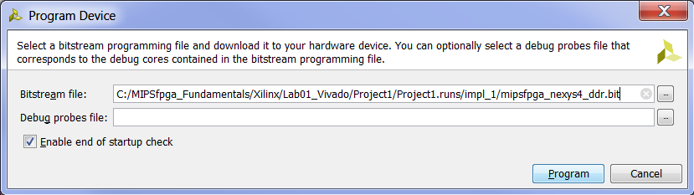
Figure 36. Program device with bitstream file

Leave the Enable end of startup box selected and click Program.

A window will pop up showing the programming progress, as shown in Figure 37. Programming the Artix-7 FPGA on the Nexys4 DDR board will take several seconds. Once it is complete, the progress window will close.

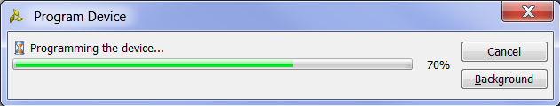
Figure 37. Program Device progress window

The MIPSfpga system is now downloaded onto the Nexys4 DDR board. Push the red reset pushbutton (labeled CPU RESET on the board, see Figure 32) to reset and start the MIPSfpga core. You will now see the LEDs display increasingly incremented values.
The MIPSfpga system is loaded with the IncrementLEDsDelay program. The machine code for this program is in the ram_rest_init.txt file located in the same directory as the Verilog files (i.e., in MIPSfpga_Fundamentals\rtl_up). The IncrementLEDsDelay program is similar to the IncrementLEDs program that you simulated earlier in this lab, but it adds a delay so that our eyes can detect the results on the LEDs. It would have been tedious to simulate thousands of cycles of delay, so we took the delay out of the program code we used for simulation (see Figure 19). The C, MIPS assembly, and machine code for IncrementLEDsDelay is shown in Figure 38 and Figure 39.
// C code  unsigned int val = 1;  volatile unsigned int* ledr_ptr;  ledr_ptr = 0xbf800000;  while (1) {  *ledr_ptr = val;  val = val + 1;  // delay  } | # MIPS assembly code  # $9 = val, $8 = memory address 0xbf800000  addiu $9, $0, 1 # val = 1  lui $8, 0xbf80 # $8=0xbf800000  L1: sw $9, 0($8) # mem[0xbf800000] = val  addiu $9, $9, 1 # val = val+1  delay: # loop 2,500,000x  lui $5, 0x026 # $5 = 2,500,000  ori $5, $5, 0x25a0  add $6, $0, $0 # $6 = 0  L2: sub $7, $5, $6 # $7 = 2,500,000 - $6  addi $6, $6, 1 # increment $6  bgtz $7, L2 # finished?  nop # branch delay slot  beqz $0, L1 # branch to L1  nop # branch delay slot
Figure 38. IncrementLEDsDelay program

24090001 // bfc00000: addiu $9, $0, 1
3c08bf80 // bfc00004: lui $8, 0xbf80
ad090000 // bfc00008: L1: sw $9, 0($8)
25290001 // bfc0000c: addiu $9, $9, 1
3c050026 // bfc00010: delay: lui $5, 0x026
34a525a0 // bfc00014: ori $5, $5, 0x25a0
00003020 // bfc00018: add $6, $0, $0
00a63822 // bfc0001c: L2: sub $7, $5, $6
20c60001 // bfc00020: addi $6, $6, 1
1ce0fffd // bfc00024: bgtz $7, L2
00000000 // bfc00028: nop
1000fff6 // bfc0002c: beq $0, $0, L1
00000000 // bfc00030: nop
Figure 39. ram_reset_init.txt memory initialization file for IncrementLEDsDelay

The next labs will show how to write, compile, download, and run C and MIPS assembly programs on the MIPSfpga system.

Lab 2
C Programming

MIPSfpga Lab 2: C Programming

Introduction
In this lab you will learn to program the MIPSfpga processor in C. You will first complete a tutorial on writing, compiling, and downloading an example C program. Then you will write your own C program to calculate the Fibonacci numbers.

MIPSfpga C Tutorial
The MIPSfpga processor is programmed using Imagination's Codescape compiler tools. If you have not already, install the Codescape SDK and OpenOCD by running the installer located here:
MIPSfpga_Fundamentals\Scripts\OpenOCD-0.9.3-Installer.exe

If you used a version earlier than 1.2 of the MIPSfpga Getting Started Guide, you will need to update the Codescape/OpenOCD installation by running the installer indicated above.

Codescape supports programming in both C and assembly language. You will use C in this lab and MIPS assembly language in Lab 3.
In this tutorial, you will learn to write and compile a simple program that reads the value of the switches on the Nexys4 DDR board and flashes their values to the LEDs. You’ll also learn to step through a program and debug it using the Bus Blaster probe and gdb, which is part of the Codescape tools.

Example C Program
Before writing your own program, we walk you through the steps of compiling, debugging, and running a program using some example code. Browse to this directory:
MIPSfpga_Fundamentals\Xilinx\Lab02_C\ReadSwitches
Open the file main.c using a text editor such as Notepad or Wordpad. The main.c file contains the ReadSwitches program, as shown in Figure 40.
int main() {
volatile int *IO_SWITCHES = (int*)0xbf800008;
volatile int *IO_LEDR = (int*)0xbf800000;
volatile unsigned int switches;

while (1) {
switches = *IO_SWITCHES;
*IO_LEDR = switches;
delay();
*IO_LEDR = 0; // turn off LEDs
delay();
}
return 0;
}

void delay() {
volatile unsigned int j;

for (j = 0; j < (1000000); j++) ; // delay
}
Figure 40. ReadSwitches C program

The following variable declarations make the variables IO_SWITCHES and IO_LEDR point to the addresses 0xbf800008 and 0xbf800000, which are the memory-mapped I/O addresses of the switches and LEDs, respectively, on the Nexys4 DDR board.

volatile int *IO_SWITCHES = (int*)0xbf800008;
volatile int *IO_LEDR = (int*)0xbf800000;

Memory-mapped I/O was described in the MIPSfpga Getting Started Guide and will be described further in Lab 5. A read to address 0xbf800008 returns the value of the switches in the lower 16 bits (and 0's in the upper 16 bits), and a write to 0xbf800000 displays the lower 16 bits of the value on the LEDs.
The program reads the switches on the FPGA board by reading address 0xbf800008:
switches = *IO_SWITCHES;

The program then writes that value to the LEDs by writing to address 0xbf800000, the memory-mapped address of the LEDs.
*IO_LEDR = switches;

The program then delays some time, turns the LEDs off, then delays again before repeating.

delay();
*IO_LEDR = 0;
delay();

The variables switches and j are declared volatile so that they are not optimized away by the compiler.
It is critical to declare variables related to hardware volatile so that the compiler does not optimize them away.

Compiling, Running, and Debugging
Now compile, run, and debug the ReadSwitches example C program on the MIPSfpga core using the following steps, described in detail below.
Step 1. Download the MIPSfpga system onto the Nexys4 DDR board
Step 2. Compile the C program
Step 3. Load the C program onto MIPSfpga using Bus Blaster
Step 4. Debug the C program using gdb as needed

Remember, that to complete these labs you need to have installed all of the required software and drivers (Vivado, Codescape, and OpenOCD, as well as Bus Blaster and Nexsy4 DDR board drivers) as described in the MIPSfpga Getting Started Guide.

Step 1. Download the MIPSfpga system to the Nexys4 DDR board
First, you will download the MIPSfpga system onto the Nexys4 DDR board. To do so, connect the Nexys4 DDR FPGA board to your computer, turn the board on, and open Vivado. Choose Flow → Open Hardware Manager from Vivado's top menu (see Figure 41).

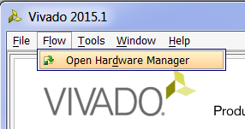
Figure 41. Open Vivado's Hardware Manager

Click on Open Target → Auto Connect (see Figure 42). Warning: Sometimes Vivado crashes at this point. Simply reopen Vivado if that happens.

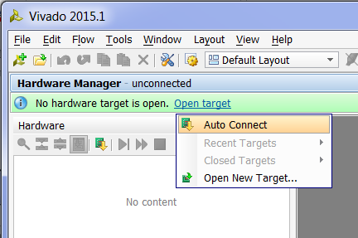
Figure 42. Autoconnect to FPGA on Nexys4 DDR board

Now click on Program device → xc7a100t_0 (see Figure 43).

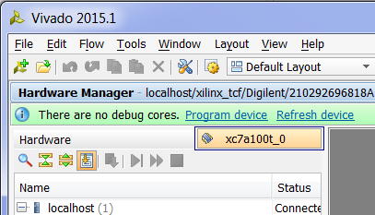
Figure 43. Program device

In the Program Device window, select the bitfile you created in Lab 1 (or the one provided at MIPSfpga_Fundamentals\Xilinx\Lab01_Vivado\mipsfpga_nexys4_ddr.bit). Then click Program. Leave the Debug probes file blank.

Click on the red CPU Reset button on the Nexys4 DDR board to reset the MIPSfpga core and begin running the pre-loaded program that displays incremented values on the LEDs.

Step 2. Compile the example program
Now compile the ReadSwitches example C program by opening a command shell. To do so, go to the Start menu, type in cmd.exe, and select . Or you can shift-right-click on an empty space on your screen and select "Open command window here". In the command shell, change to the MIPSfpa_Fundamentals\Xilinx\Lab02_C\ReadSwitches directory. For example, if MIPSfpga_Fundamentals is in C:\ type:

cd C:\MIPSfpga_Fundamentals\Xilinx\Lab02_C\ReadSwitches

Compile the example C code by typing make at the prompt in the command window:

make

This runs the Makefile, which compiles the user code (found in main.c) with the boot code (found in boot.S and the other .S files). Open and view the Makefile using a text editor such as Notepad or Wordpad. For future programs, any C program files can be placed under "CSOURCES="

CSOURCES= \
main.c

Below is a brief description of the main parts of the Makefile. The top part of the file gives the names and locations of the compiler tools (gcc, ld, objdump, etc.). These compiler tools are provided with Codescape. They are GNU tools targeted to the MIPSfpga processor.

ifndef MIPS_ELF_ROOT
$(error MIPS_ELF_ROOT must be set to point to toolkit installation root)
endif

CC=mips-mti-elf-gcc
LD=mips-mti-elf-ld
OD=mips-mti-elf-objdump
OC=mips-mti-elf-objcopy
SZ=mips-mti-elf-size

The next part of the Makefile indicates the flags to use for compiling and loading the program.

CFLAGS = -O1 -g -EL -c -msoft-float -march=m14kc
LDFLAGS = -EL -msoft-float -march=m14kc -Wl,-Map=FPGA_Ram_map.txt

For the C flags, -O1 says to use optimization level 1. You can change this to higher optimization levels as desired, for example optimization level 2 (-O2) or 3 (-O3). It is typically a good idea to debug your code using the lowest optimization level (0 or 1). Then, once your code is working, increase the optimization level to produce faster, denser code. –march=m14kc indicates to target the M14K MIPS microAptiv architecture, -msoft-float says that there is no floating-point unit and to use software floating point routines instead.

The LDFLAGS are used when creating the ELF file, which will provide the program code as well as information about how to load the program and data into the MIPSfpga system's memory. Generally, the LDFLAGS indicate to not generate any floating point instructions (–msoftfloat) and to target the M14K MIPS architecture. The file indicated (FPGA_Ram_map.txt) describes how and where the program, boot code, and data will be loaded into memory, according to the physical memory map shown in Lab 1. The rest of the LD flags (LDFLAGS += ...) indicate where to place the program, boot code, stack, etc. in memory.

The remainder of the Makefile describes how to compile the program and to clean the directory (i.e., remove files created during compilation). To clean the directory of files created during compilation, type the following at the command prompt:

make clean

If you just cleaned the directory, compile the program (main.c) again by typing make at the command prompt. Notice that at the end of compilation, the Makefile outputs the size of the executable, as shown in Error! Reference source not found..

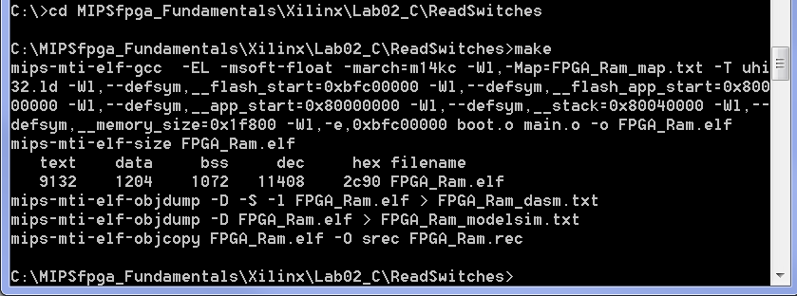Figure 44. Command shell output of Makefile

The text is 9132 bytes, the data is 1204 bytes and the bss segment (static data that should be initialized to 0) is 1072 bytes for a total of 11408 = 0x2c90 bytes. This fits easily within the MIPSfpga memory space. However, you will want to keep your eye on these numbers for larger programs to make sure they fit within MIPSfpga's physical memory.

You should now see the following files in the ReadSwitches directory:
- FPGA_Ram.elf
- FPGA_Ram_dasm.txt
- FPGA_Ram_modelsim.txt
- main.o

FPGA_Ram.elf is the main output of compilation. It is the ELF (executable and linkable format) executable that you will use to load the program into the memory of the MIPSfpga core.
FPGA_Ram_dasm.txt is a disassembled version of the executable. It is basically a human-readable version of the ELF file that shows instruction addresses and instructions interspersed with the line numbers of the higher-level (assembly or C) source code.
FPGA_Ram_modelsim.txt is another human-readable version of the ELF file, but it is not interspersed with the source code information. It shows the memory addresses and corresponding instructions/data, including those memory addresses that should be initialized to 0. We will use this file to create memory definition files for simulation of compiled programs using Modelsim.
main.o is the executable and linkable version of main.c.

Open FPGA_Ram_dasm.txt using a text editor to see where the boot code and user code will be placed. The top of the file shows the boot code, starting at 0x9fc00000. Recall that this virtual address maps to physical address 0x1fc000000, which is the physical address of the first instruction fetched upon reset of the MIPSfpga core.

Near the bottom of the file, you can view the user code from main.c, starting at 0x8000075c. This will map to physical addresses starting at 0x0000075c.

Step 3. Load the C program onto the MIPSfpga system using Bus Blaster
Now that the example program is compiled, you will load it onto the MIPSfpga core using the Bus Blaster probe. First, connect the Bus Blaster probe to the Nexys4 DDR board, as shown in Figure 45. Do so by connecting the two rows of 6 header pins into the small Adapter Board. Then connect the Adapter Board into the PMOD-B port of the Nexys4 DDR board, as shown in the figure. Connect one side of the ribbon cable into the small Adapter board and the other side into the Bus Blaster probe. Connect one side of the USB cable between the Bus Blaster probe and your computer. Remember, it is best to use the same port for the Bus Blaster probe as the one on which you installed the drivers for it.
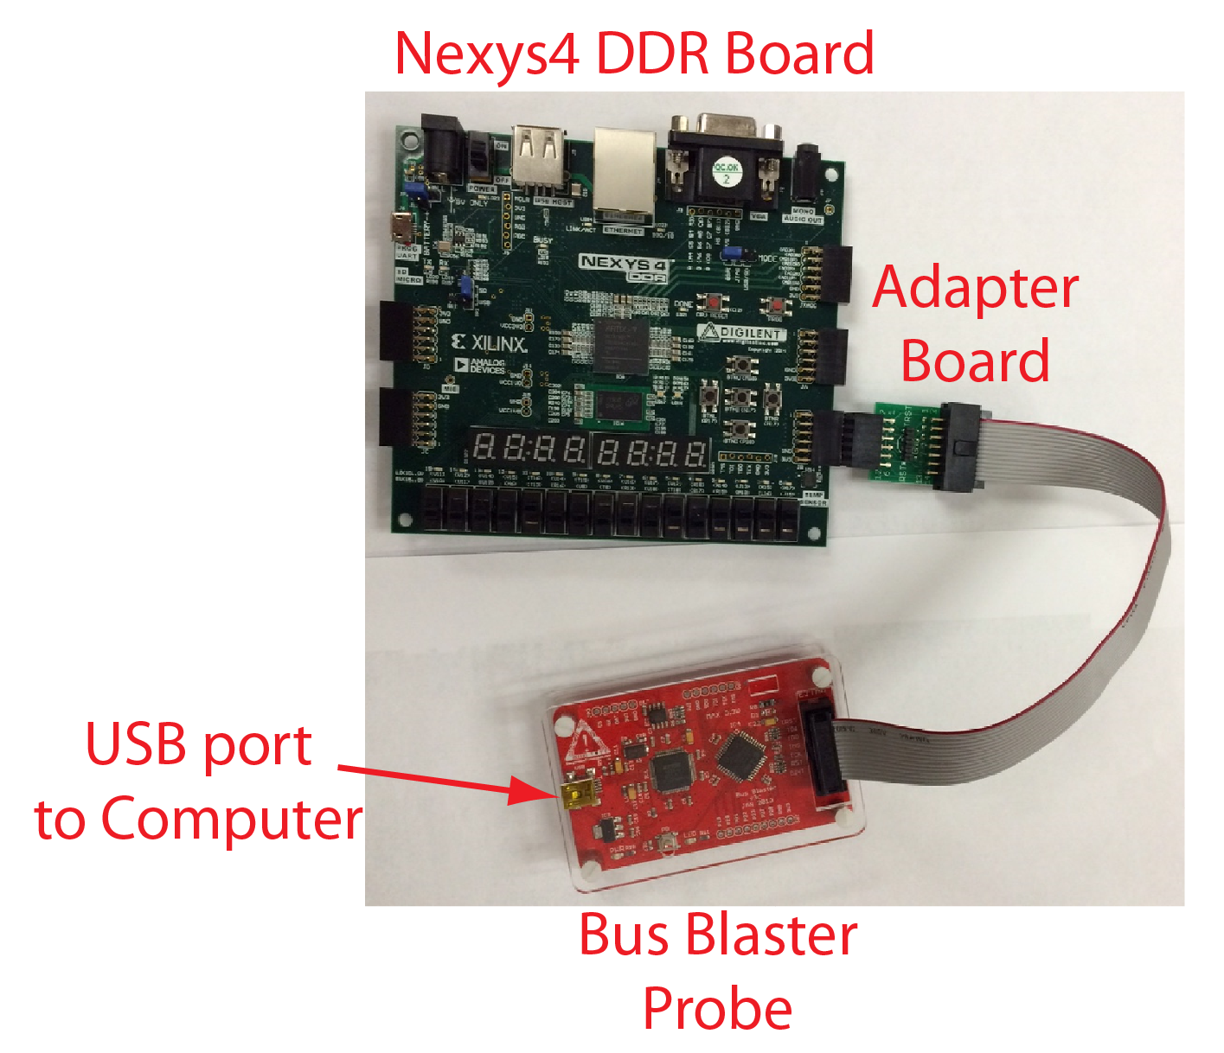
Figure 45. Nexys4 DDR board connected to the Bus Blaster probe

Now open a command shell (i.e., Start menu → cmd.exe.) In the command shell, change to the MIPSfpga_Fundamentals\Scripts\Nexys4_DDR directory. For example, if MIPSfpga_Fundamentals is located on the C drive, type the following at the shell prompt:
cd C:\MIPSfpga_Fundamentals\Scripts\Nexys4_DDR
Now you will run the loadMIPSfpga.bat script that will (1) compile the program, (2) set up a connection to the MIPSfpga core using OpenOCD, (3) download the program onto the MIPSfpga system, and (4) allow you to use the Gnu debugger (gdb) to load and debug the program on the MIPSfpga core.
Run the loadMIPSfpga.bat batch script supplying the directory of the ReadSwitches program as the argument. For example, if MIPSfpga_Fundamentals is on the C drive, at the command font, type:
loadMIPSfpga.bat C:\MIPSfpga_Fundamentals\Xilinx\Lab02_C\ReadSwitches
Or you could type:
loadMIPSfpga.bat ..\..\Xilinx\Lab02_C\ReadSwitches
After running the script, you will see the ReadSwitches program running on the MIPSfpga core. Recall that the ReadSwitches program repeatedly reads the value of the switches and flashes that value on the LEDs. Toggle some of the switches at the bottom of the Nexys4 DDR board and watch as the corresponding LEDs flash.
The loadMIPSfpga.bat script first opens a shell to compile the specified program using make. It then opens up two more shells to create the OpenOCD connection and run gdb. After you are finished with a program, you need to close these two windows.

Step 4. Debug the C program using gdb as needed
Although this ReadSwitches program works and requires no debugging, we will show you how to go through the process of debugging using gdb, supplied as part of the Codescape SDK.
Click on the gdb command shell that was opened by the loadMIPSfpga.bat script in the previous step. Enter the sequence of commands shown in Table 1 to halt the program, set breakpoints, view variable and register values, etc.
Table 1. gdb command sequence
Command | Description
monitor reset halt | Reset and stop the processor. Notice the program stopped running.  Shortcut: mo reset halt
b main | Set a breakpoint at the main function. (Short for: "break main".)  Notice that the breakpoint is set at 0x800007b4, just after the code for the delay function and stack operations (located at addresses 0x8000075c – 0x800007b0).  Note that you can set breakpoints even when the processor is running, but the breakpoints will take effect only when the processor is halted (mo reset halt).
b *0x800007b8 | Set a breakpoint at instruction address 0x800007b8. In the ReadSwitches C program, this is the load word instruction (lw) that reads the value of the switches (see MIPSfpga_Fundamentals\Xilinx\Lab02_C\ReadSwitches\FPGA_Ram_dasm.txt)  800007b8: 8e020008 lw v0,8(s0)  Note that you could also have typed: b 20  This would set a breakpoint at line 20 of main.c
b *0x800007c4 | Set a breakpoint at instruction address 0x800007c4. In the ReadSwitches C program, this is the store word instruction (sw) that writes to the LEDs (see MIPSfpga_Fundamentals\Xilinx\Lab02_C\ReadSwitches\FPGA_Ram_dasm.txt)  800007c4: ae020000 sw v0,0(s0)
i b | List the breakpoints. (Short for: "info breakpoint".) At this point it will list the breakpoint at instruction addresses 0x800007b4 (main), 0x800007b8, and 0x800007c4.
c | Continue the processor execution. (Short for: "continue".) It will stop at the first breakpoint, in this case, when it gets to main (instruction address 0x800007b4).
x/3i $pc | Prints 3 instructions starting with the current instruction ($pc is the program counter and contains the address of the current instruction).  800007b4: lui s0,0xbf80  800007b8: lw v0,8(s0)  800007bc: sw v0,16(sp)
x/3x $pc | Prints 3 instructions in hexadecimal, starting at the address specified.
c | Continue to the next break point, which is at 0x800007b8.
stepi | Executes a single instruction. For example, now you will see the PC increment to 0x800007bc.  Shortcut: si
si | Step one more instruction. (You can also simply press the Enter key to repeat the last gdb command.)
p switches | Now that the switches have been read, we can print the value of the variable switches. (Short for: "print switches".) For example, if the 3 least significant switches are 1 (i.e., in the UP position), switches will have the value 7.
p/x switches | Prints the value of the switches variable in hexadecimal.
p/x &switches | Prints the address of the switches variable
i r | Print the value of all registers. (Short for: "info registers".)
i r v0 | Print the value of register v0 only. At this point, v0 holds the value of the FPGA board switches. This value will be written to the LEDs by the store word (sw) instruction at 0x800007c4.
c | Continue program execution. (Short for: "continue".) Execution is now at 0x800007c4, the store word instruction that will write the value of the switches to the LEDs.
i r s0 | Print the value of register s0. s0 currently holds the memory-mapped I/O address of the LEDs: 0xbf800000.
i r v0 | Print the value of register v0. v0 holds the value of the switches that will get written to the LEDs.
si | Execute the store word instruction and watch as the LEDs are updated to the value of the switches.
d 1 | Delete breakpoint 1 (type i b to list the breakpoints with their numbers). This deletes the breakpoint at the beginning of main.
monitor reset run | Reset and run the processor. This will run the processor without breakpoints, even if breakpoints have been set.  Shortcut: mo reset run

For a list of other gdb commands, refer to the GDB User Manual available as a link on this webpage:
http://www.gnu.org/software/gdb/documentation/

MIPSfpga Exception Handler
MIPSfpga can enter the exception handler for various reasons including accessing an illegal address or attempting to execute an unknown instruction. Here we show how to write an exception handler for MIPSfpga, so that you will know when an exception occurs. Browse to MIPSfpga_Fundamentals\Xilinx\Lab02_C\ExceptionHandler and open main.c. View the _mips_handle_exception function, as shown below. This function, which will be called upon an exception, displays 0x8001 on the LEDs to indicate that an exception occurred. You could choose a different value to output. If this function does not exist in your code, upon an exception, the processor simply hangs.

void _mips_handle_exception(void* ctx, int reason) {
volatile int *IO_LEDR = (int*)0xbf800000;

*IO_LEDR = 0x8001; // Display 0x8001 on LEDs to indicate error state
while (1) ;
}
To illustrate what happens when an exception occurs, the code in this program intentionally causes an exception by attempting to write to address 0 be executing the code below.
volatile int *test_error = (int*)0x0;
*test_error = 56; // write to address 0 will cause an exception

Compile and run this code on the MIPSfpga system. At a command shell prompt, change to the MIPSfpga_Fundamentals\Scripts\Nexys4_DDR directory and type:
loadMIPSfpga.bat ..\..\Xilinx\Lab02_C\ExceptionHandler
You will want to include this exception handler function (_mips_handle_exception) in all of your code to detect when an exception occurs.

Fibonacci Numbers
Now you will write your own C program, compile it, and run it on MIPSfpga. Create a program that will calculate and display the first 11 Fibonacci numbers on the LEDs. Each number in the Fibonacci series is the sum of the previous two numbers. Table 2 lists the first few numbers in the series.
Table 2: Fibonacci Series
n | 1 | 2 | 3 | 4 | 5 | 6 | 7 | 8 | 9 | 10 | 11 | …
fib(n) | 1 | 1 | 2 | 3 | 5 | 8 | 13 | 21 | 34 | 55 | 89 | …
fib(n) | 0x1 | 0x1 | 0x2 | 0x3 | 0x5 | 0x8 | 0xd | 0x15 | 0x22 | 0x37 | 0x59

We can also define the fib function for negative values of n. To be consistent with the definition of the Fibonacci series, what would the following values be?
fib(0) = ____
fib(-1) = ____
These values are useful when writing a loop to compute fib(n) for all non-negative values of n.
Make a copy of the Lab02_C/ExceptionHandler folder and rename the new folder Fibonacci. Write your program in the main.c file in that folder. Your program should compute the Fibonacci numbers for n = 1…11 and output each Fibonacci number to the LEDs. The LEDs should display the Fibonacci numbers in binary, with a delay between each number so that they are viewable.
Once you have finished writing your program, use the make command to compile it. If there are any errors, fix them and recompile.
After your Fibonacci program compiles without errors, load it onto the MIPSfpga core by:
- Opening a command shell
- Changing to the MIPSfpga_Fundamentals\Scripts\Nexys4_DDR directory
- Typing at the command prompt:
loadMIPSfpga.bat C:\MIPSfpga_Fundamentals\Xilinx\Lab02_C\Fibonacci
Table 2 lists the Fibonacci numbers in hexadecimal to help you read the binary values on the LEDs. In later labs, you will expand the MIPSfpga hardware to enable you to use the 7-segment displays available on the Nexys4 DDR FPGA board. But for now, remember that you can also use breakpoints in gdb to examine the values produced by your program.

Lab 5
Memory-Mapped I/O: 7-Segment Displays

MIPSfpga Lab 5:
Memory-Mapped I/O: 7-Segment Displays

Introduction
In this lab you will learn about memory-mapped inputs and outputs (I/O) by building hardware modules to expand the capability of the MIPSfpga system so that it can write to the 7-segment displays on the Nexys4 DDR board. You will then test your new hardware by simulating a short sequence of MIPS assembly code. At the end of the lab, you will write C programs that display the value of the switches on the 7-segment displays.

MIPSfpga Memory-Mapped I/O
A processor uses the memory interface to interact with peripheral devices, such as the switches, LEDs, and 7-segment displays on the Nexys4 DDR FPGA board. Memory-mapped I/O enables a processor to write to or read from a peripheral device in the same manner that it reads or writes memory. Each peripheral device is assigned one or more memory addresses. When the processor accesses such a memory address, the peripheral device is accessed instead of memory. The MIPSfpga system uses the AHB-Lite bus to access external memory and peripherals.

AHB-Lite Bus
The AHB-Lite bus has a clock, write enable, address, and read and write data signals (HCLK, HWRITE, HADDR, HRDATA, and HWDATA), as shown in Figure 46. The "H" prefix indicates that they are part of the AHB-Lite bus. Memory and peripherals are connected to this interface to receive and supply data. The MIPSfpga core sends these signals to the AHB-Lite Bus:
- HCLK: the 50 MHz system clock
- HWRITE: write enable (1 when writing, 0 when reading)
- HADDR: the address being read or written
- HWDATA: the data being written on a write
The MIPSfpga core receives the following input from the AHB-Lite bus:
- HRDATA: the read data produced by memory or the peripherals
The MIPSfpga system has three modules on the AHB-Lite bus: two memories (RAM0 and RAM1) and a general-purpose I/O module (GPIO). RAM0 contains the boot code and RAM1 contains the user code and data. The GPIO unit interfaces with the LEDs, switches, and pushbuttons on the Nexys4 DDR board.
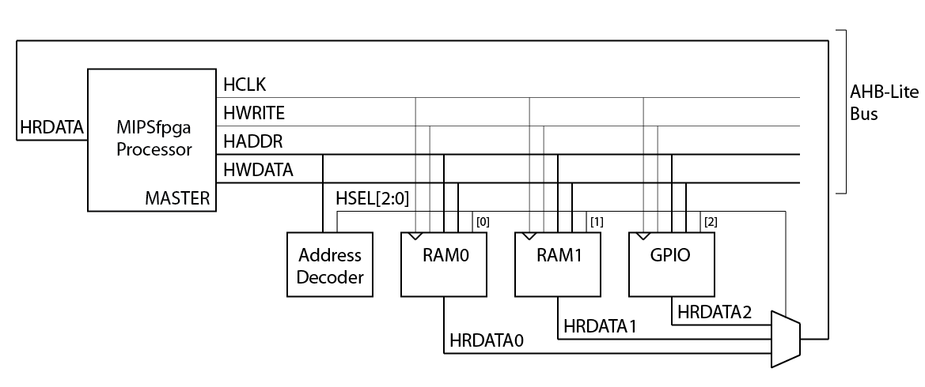
Figure 46. MIPSfpga processor with three peripheral devices

In addition to the three peripherals, the memory-mapped I/O interface requires an Address Decoder and a multiplexer. Depending on the address generated by the processor (HADDR[31:0]), the Address Decoder will enable the processor to access one of the three modules. The Address Decoder generates a select signal HSEL[2:0] that is used by the modules and by the 3:1 multiplexer.
RAM0 holds the boot code (virtual addresses 0xbfc00000-0xbfc1fffc = physical addresses 0x1fc00000-0x1fc1fffc). RAM1 holds the user code (virtual addresses 0x80000000-0x8003fffc = physical addresses 0x00000000-0x0003fffc). The LEDs, switches, and pushbuttons on the Nexys4 DDR board are mapped to virtual memory addresses 0xbf800000-0xbf80000c, as shown in Table 3. The processor code uses virtual memory addresses, and the AHB-Lite bus receives physical addresses. The memory management unit (MMU) on the MIPSfpga core performs this address translation.
Table 3. Memory addresses for Nexys4 DDR FPGA board
Virtual address | Physical address | Signal Name | Nexys4 DDR
0xbf80 0000 | 0x1f80 0000 | IO_LEDR | LEDs
0xbf80 0008 | 0x1f80 0008 | IO_SW | switches
0xbf80 000c | 0x1f80 000c | IO_PB | U, D, L, R, C pushbuttons

The following sequence of MIPS assembly instructions writes the value 5 to the LEDs:
lui $8, 0xbf80 # $8 = 0xbf800000 (address of LEDs)
addi $9, $0, 5 # $9 = 5
sw $9, 0($8)

Recall that load-upper-immediate (lui) loads the 16-bit value 0xbf80 into the upper half of $8 and clears the lower half. Upon execution of the store word instruction (sw), HADDR = 0x1f800000, HWRITE = 1, and HWDATA = 5. The Address Decoder detects that address 0x1f800000 belongs to the general-purpose I/O (GPIO) peripheral and asserts HSEL[2], the select signal associated with that peripheral. The GPIO module detects that HSEL[2] and HWRITE are asserted. Because the GPIO module could potentially write to multiple peripherals, the module uses the address to determine that the LEDs should be written with the value on the HWDATA bus. Specifically, a register whose output is physically connected to the LEDs is updated with the value on HWDATA. That way, the value persists until the LEDs are written again by a later instruction.
Similarly, the following sequence of code reads the value of the switches:
lui $8, 0xbf80 # $8 = base address of the I/O
lw $9, 8($8) # $9 = value of the switches

Upon execution of the load word instruction (lw), HADDR = 0x1f800008 and HWRITE = 0 (indicating a read). The Address Decoder detects that address 0x1f800008 belongs to the GPIO peripheral and asserts HSEL[2] (and keeps the other select signals HSEL[1] and HSEL[0] low). The GPIO module detects the address corresponding to the switches and selects to send the value of the switches to its read data output, HRDATA2. The select signals HSEL[2:0] control the multiplexer. Because HSEL[2] is asserted, the multiplexer sends HRDATA2 through to HRDATA. The MIPSfpga processor then reads the value on HRDATA, as it would with a typical read from memory, and stores that value in $9. Thus, after the lw completes, $9 contains the value of the switches.
The hardware for the MIPSfpga AHB-Lite modules is located in the mipsfpga_ahb module and its submodules. It is best to view this module in your Vivado project, so that the hierarchy is clear. Open the Vivado project that you created in Lab 1 (i.e., in MIPSfpga_Fundamentals\Xilinx\Lab01_Vivado\Project1). In the Project Manager window, expand mipsfpga_nexys4_ddr, then mipsfpga_sys, then mipsfpga_ahb to view the mipsfpga_ahb hierarchy, as shown in Figure 47. Double-click on any of the modules and the Verilog file will open in the neighboring panel.

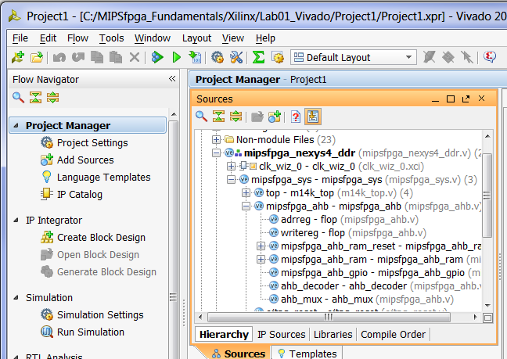
Figure 47. mipsfpga_ahb hierarchy shown in Vivado

For example, double-click on mipsfpga_ahb to view the interface signals (see Figure 48). Notice all of the AHB-Lite signals from Figure 46 (HCLK, HADDR, HWRITE, HWDATA, and HRDATA). Additional AHB-Lite signals are also available if desired. The module also has the memory-mapped I/O signals IO_Switch, IO_PB, and IO_LEDR that connect to the switches, pushbuttons, and LEDs on the Nexys4 DDR board. IO_LEDG is not used on the Nexys4 DDR board.

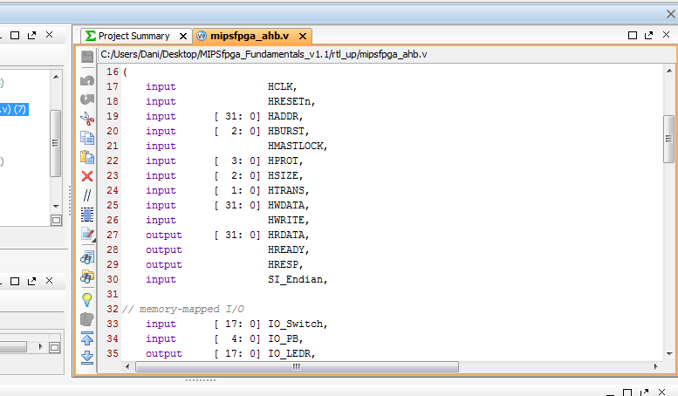
Figure 48. mipsfpga_ahb interface signals

The modules instantiated within mipsfpga_ahb are the three peripherals, address decoder, and multiplexer shown in Figure 46. The corresponding Verilog module names are given in Table 4. View the Verilog code to see how the functionality described above is implemented.
Table 4. AHB-Lite Modules
Name from Figure 46 | Module Name
RAM0 | mipsfpga_ahb_ram_reset
RAM1 | mipsfpga_ahb_ram
GPIO | mipsfpga_ahb_gpio
Address Decoder | ahb_decoder
Multiplexer (for HRDATA) | ahb_mux

The GPIO module (mipsfpga_ahb_gpio) interfaces with the general-purpose I/O on the Nexys4 DDR board. The MIPSfpga system includes access to the LEDs, switches and pushbuttons on the board. In this and the next labs, you will expand the MIPSfpga functionality to extend to other peripherals, starting with the eight 7-segment displays available on the Nexys4 DDR board.

7-Segment Displays
Digits can be represented using 7-segment displays, as shown in Figure 49. Each of the seven segments is labeled a through g. The numbers 0 through F light up the segments shown in Figure 50. For example, the number 0 lights up all but the middle segment, g.
Figure 49. Seven-segment display

Figure 50. Seven-segment display function

Given an input number ranging from 0x0 – 0xF, we will show how to expand the MIPSfpga system to drive the 7-segment displays to show that number. Each segment of the display is low-asserted, so it turns ON when it is 0.

The truth table below (Table 5) shows the inputs (a 4-bit value from 0-15) and outputs for a 7-segment display decoder that takes in a 4-bit number and produces the value of the segments corresponding to that number. So, for example, with an input of "0", the 7-segment display decoder turns all but the middle segment (S_{g}) ON. Thus, the first row for Hexadecimal digit "0" shows all the segments as 0 except S_{g}. (Remember that the segments are low-asserted, so they are ON when they receive 0.) The digit "1" should only have S_{b} and S_{c} ON (so S_{b} and S_{c} are 0 in that row), and so forth.

Table 5. Truth table for 7-segment display decoder
Hexadecimal Digit | Inputs |  |  |  | Outputs
 | D₃ | D₂ | D₁ | D₀ | S_{a} | S_{b} | S_{c} | S_{d} | S_{e} | S_{f} | S_{g} | HEX
0 | 0 | 0 | 0 | 0 | 0 | 0 | 0 | 0 | 0 | 0 | 1 | 01
1 | 0 | 0 | 0 | 1 | 1 | 0 | 0 | 1 | 1 | 1 | 1 | 4f
2 | 0 | 0 | 1 | 0 | 0 | 0 | 1 | 0 | 0 | 1 | 0 | 12
3 | 0 | 0 | 1 | 1 | 0 | 0 | 0 | 0 | 1 | 1 | 0 | 06
4 | 0 | 1 | 0 | 0 | 1 | 0 | 0 | 1 | 1 | 0 | 0 | 4c
5 | 0 | 1 | 0 | 1 | 0 | 1 | 0 | 0 | 1 | 0 | 0 | 24
6 | 0 | 1 | 1 | 0 | 0 | 1 | 0 | 0 | 0 | 0 | 0 | 20
7 | 0 | 1 | 1 | 1 | 0 | 0 | 0 | 1 | 1 | 1 | 1 | 0f
8 | 1 | 0 | 0 | 0 | 0 | 0 | 0 | 0 | 0 | 0 | 0 | 00
9 | 1 | 0 | 0 | 1 | 0 | 0 | 0 | 1 | 1 | 0 | 0 | 0c
A | 1 | 0 | 1 | 0 | 0 | 0 | 0 | 1 | 0 | 0 | 0 | 08
B | 1 | 0 | 1 | 1 | 1 | 1 | 0 | 0 | 0 | 0 | 0 | 60
C | 1 | 1 | 0 | 0 | 1 | 1 | 1 | 0 | 0 | 1 | 0 | 72
D | 1 | 1 | 0 | 1 | 1 | 0 | 0 | 0 | 0 | 1 | 0 | 42
E | 1 | 1 | 1 | 0 | 0 | 1 | 1 | 0 | 0 | 0 | 0 | 30
F | 1 | 1 | 1 | 1 | 0 | 1 | 1 | 1 | 0 | 0 | 0 | 38

Build 7-segment decoder
Write a Verilog module that describes the seven-segment display decoder in hardware. The module declaration is provided for you in:
MIPSfpga_Fundamentals\Xilinx\Lab05_7seg\VerilogFiles\mipsfpga_ahb_sevensegdec.v
The module has a 4-bit input, data[3:0], and a 7-bit output, segments[6:0], corresponding to each of the segments a-g. Test your hardware in simulation using XSIM and debug as needed. In the next step, you will use this module to drive the 7-segment displays on the Nexys4 DDR board.

7-Segment Displays on the Nexys4 DDR board
The Nexys4 DDR board has eight 7-segment digits. All eight of the digits on the Nexys4 DDR board are connected to the same low-asserted segment pins, referred to as CA, CB, CC,…,CG. However, each digit has its own enable which is also low-asserted. Figure 51 shows the eight 7-segment displays on the Nexys4 DDR board. CA is connected to the cathode of the A segment for all eight displays, CB to the cathode of the B segment for all displays, and so forth. Each digit has an enable signal, corresponding to the respective bit of the signal AN[7:0]. AN[7:0] is connected via an inverter, to the anode of all segments for the respective digit. For example, if AN[7] is 0, digit 7 will be driven to the values on CA…CG.
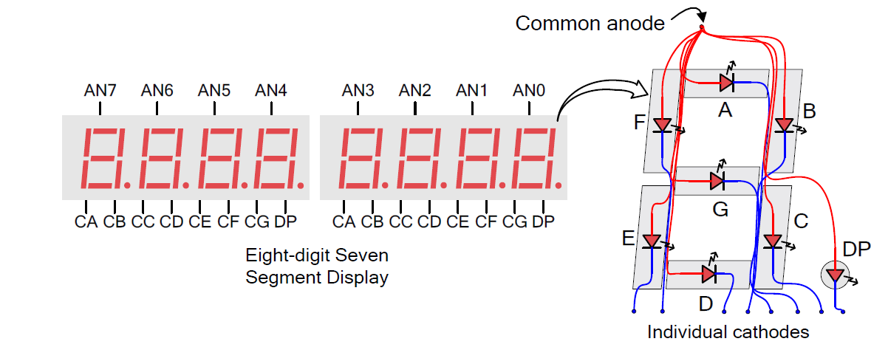
Figure 51. Eight 7-segment displays on the Nexys4 DDR board
(© Nexys4 DDR Reference Manual)
To drive each segment to a different value, the enables (AN[7:0]) and segment values (CA…CG) must be driven sequentially, at a rapid enough speed that our eyes don't detect the flicker. For example, to drive display 0 and 1 to the values 3 and 9, we drive CA…CG to display the value 3, and then drive AN[0] LOW, then we drive CA…CG to display the value 9 and drive AN[1] LOW. If we refresh each digit about every 2 ms, our eyes can't detect any flicker.
Build HDL module to drive Nexys4 DDR 7-segment displays
Now you will write a Verilog module that drives the eight 7-segment displays on the Nexys4 DDR board. The module declaration is provided in:
MIPSfpga_Fundamentals\Xilinx\Lab05_7seg\VerilogFiles\mipsfpga_ahb_sevensegtimer.v
The module receives the number to display on each of the eight digits (DISP0[3:0] – DISP7[3:0]) and a signal indicating which of the eight displays are enabled (EN[7:0]). It also receives the 50 MHz clock (clk) and a low-asserted reset signal (resetn) as inputs. The outputs are the 7-segment display enables (DISPENOUT[7:0]) and the values of the 7 segments, A-G (DISPOUT[6:0]). Later in the lab you will connect these outputs through to the top-level module (mipsfpga_nexys4_ddr) so that they drive the eight display enables (AN[7:0]) and the seven segment pins (CA…CG).
Your module should drive each enabled digit sequentially about every 2 ms. You will need to use your 7-segment display decoder that you wrote in the previous section. Note that you could expand the functionality of this module to include the decimal point (DP) if desired. Test your hardware in simulation using XSIM and debug as needed.

Adding Seven-Segment Display Functionality to the GPIO AHB-Lite Module
Now that you have written the hardware modules that will write the eight 7-segment displays, add functionality to the MIPSfpga system to interface with the displays. Your goal is to enable the user to write to the eight 7-segment displays using sw. Start by doing the following:
- Assign memory-mapped I/O addresses to the enable signal and each of the eight digits
- Modify the GPIO module to detect these addresses and store the written data to the associated memory-mapped I/O registers
- Connect these registers to the mipsfpga_ahb_sevensegtimer module you just created

To make these changes, you will need to modify the following files (found in the MIPSfpga_Fundamentals\rtl_up directory):
- mipsfpga_ahb_const.vh
- mipsfpga_ahb_gpio.v

Below is some guidance for each of the above steps.
- Assign memory-mapped I/O addresses
Assign nine addresses to the seven-segment displays, one for the enable and eight for the value of each digit, as shown in Table 6. The user will write to these addresses to set the enable and the digit values.
Table 6. Memory addresses for Nexys4 DDR FPGA 7-segment displays
Virtual address | Physical address | Signal Name | Nexys4 DDR
0xbf80 0010 | 0x1f80 0010 | SEGEN_N[7:0] | AN[7:0]
0xbf80 0014 | 0x1f80 0014 | SEG0_N[3:0] | Digit 0 value
0xbf80 0018 | 0x1f80 0018 | SEG1_N[3:0] | Digit 1 value
0xbf80 001c | 0x1f80 001c | SEG2_N[3:0] | Digit 2 value
0xbf80 0020 | 0x1f80 0020 | SEG3_N[3:0] | Digit 3 value
0xbf80 0024 | 0x1f80 0024 | SEG4_N[3:0] | Digit 4 value
0xbf80 0028 | 0x1f80 0028 | SEG5_N[3:0] | Digit 5 value
0xbf80 002c | 0x1f80 002c | SEG6_N[3:0] | Digit 6 value
0xbf80 0030 | 0x1f80 0030 | SEG7_N[3:0] | Digit 7 value

To define these memory-mapped addresses, modify the mipsfpga_ahb_const.vh Verilog header file. In Vivado, open Project1. Browse to mipsfpga_ahb_const.vh in the Project Manager window (as shown in Figure 52), under Design Sources → Verilog Header.

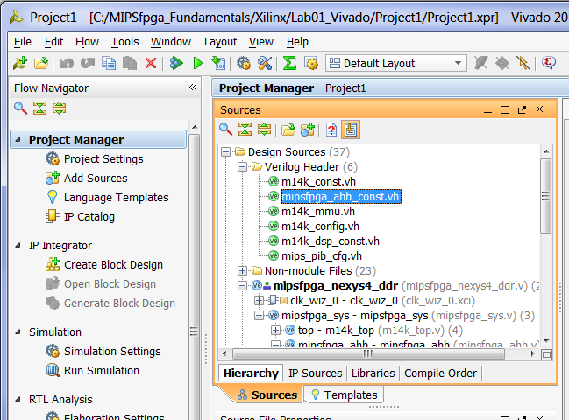
Figure 52. mipsfpga_ahb_const.vh Verilog header file
Define the new memory-mapped I/O addresses for the 7-segment displays as H_7SEGEN_ADDR, H_7SEG0_ADDR, … H_7SEG7_ADDR. The Address Decoder (ahb_decoder module) uses the most significant bits of the address to detect which of the three AHB slaves to enable (the reset RAM, program RAM, or GPIO module). Then, once selected, the GPIO module uses the lower bits of the address to determine which of its peripherals should be written or read. Bits 5:2 of the memory-mapped I/O address are saved in another constant: H_*_IONUM, lower in the mipsfpga_ahb_const.vh file, as shown below:
`define H_LEDR_IONUM (4'h0)
`define H_LEDG_IONUM (4'h1)
`define H_SW_IONUM (4'h2)
`define H_PB_IONUM (4'h3)

For example, the switches are mapped to physical address 0x1f800008, so bits 5:2 are 0x2 (i.e., H_SW_IONUM is 4'h2).
Name the I/O numbers for the 7-segment display variables: H_7SEGEN_IONUM, H_7SEG0_IONUM, etc. For example since the address for the 7-segment enable is 0x1f800010, H_7SEGEN_IONUM is 0x4.

2. Modify the GPIO module
Now modify the GPIO module to detect the nine memory-mapped I/O addresses you just defined and write the data (HWDATA) to those registers when the corresponding address is detected. In Project1 in Vivado, open mipsfpga_ahb_gpio.v. In the module declaration, declare and output the enable and segment signals (A-G). Name these signals IO_7SEGEN_N[7:0] and IO_7SEG_N[6:0], respectively. In a higher-level module, these will drive the enables (AN[7:0]) and segment values (CG…CA) on the Nexys4 DDR board.
You must now create 9 registered values that hold the value of the enables and the values to display on the eight 7-segment display digits. The user will write to these registers using memory-mapped I/O. Name the registered signal that holds the enables SEGEN_N[7:0]. Name the registers that each hold the 4-bit values to display on the eight digit SEG0_N[3:0], …,SEG7_N[3:0]. Modify the GPIO module so that these registers get written when the correct address is detected.

3. Connect these registers to the mipsfpga_ahb_sevensegtimer module you just created
Now, within the GPIO module, instantiate and connect the mipsfpga_ahb_sevensegtimer module that you built earlier in this lab. You will connect its inputs to the memory-mapped I/O registers (as well as the clock and reset signals) and its outputs to the 7-segment display signals (IO_7SEGEN_N and IO_7SEG_N).

Connect the 7-Segment Display Signals to the Nexys4 DDR Board
Now you will connect the output signals from the AHB GPIO module through to drive the 7-segment displays on the Nexys4 DDR board. Feed the output signals from the GPIO module (IO_7SEGEN_N and IO_7SEG_N) up through the levels of hierarchy until they reach the Nexys4 DDR board (i.e., outputs of the mipsfpga_nexys4_ddr module). To do so, you will need to modify the following modules:
- mipsfpga_ahb.v
- mipsfpga_sys.v
- mipsfpga_nexys4_ddr.v

In the highest-level module (mipsfpga_nexys4_ddr.v), name the output signals that will drive the 7-segment display: CA, CB, CC, CD, CE, CF, CG, and AN[7:0]. Recall that CA…CG drive the segments and AN[7:0] drives the enables.
You will also modify the Xilinx Design Constraint (.xdc) file. Open this file from Project1 (in Vivado) by expanding Constraints → constrs_1 in the Project Manager window as shown in Figure 53. Double-click on the mipsfpga_nexys4_ddr.xdc file to open it. The XDC file assigns the signal names, AN[7:0] and CA – CG, to pins on the Artix-7 FPGA that are physically connected to the 7-segment display inputs on the Nexys4 DDR board using wire traces.

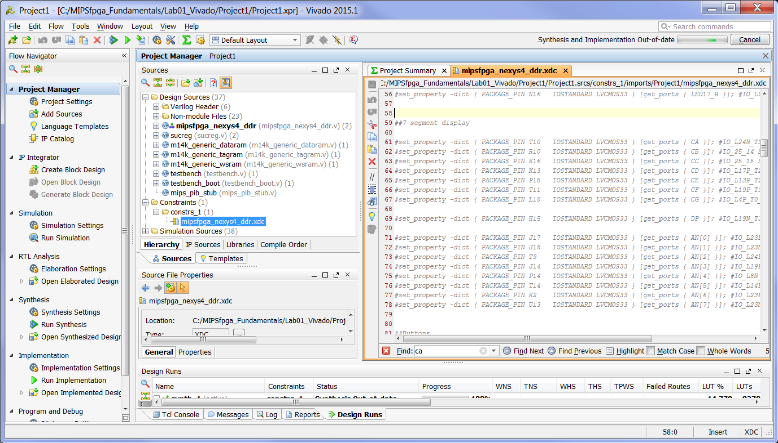
Figure 53. Opening Xilinx Design Constraint file

With the .xdc file open in Vivado, search for (ctrl-F) "segment" to find the listing of 7-segment display outputs, as shown in Figure 53. The information about which pins are connected to the 7-segment displays is already available in the file – it needs only be uncommented. Do so by deleting the # before each line you'd like to use. For example, signal CA that drives the A segment of the 7-segment displays connects to pin T10 on the FPGA by the following line:
set_property -dict { PACKAGE_PIN T10 IOSTANDARD LVCMOS33 } [get_ports { CA }]; #IO_L24N_T3_A00_D16_14 Sch=ca

This pin is connected via a wire trace to the segment A input of the 7-segment displays on the Nexys4 DDR board. CB should output to the R10 Artix-7 pin, and so on. The signals driving the anodes of the 7-segment displays (AN[7:0]) are also assigned Artix-7 package pins. Leave the DP signal is commented out (#) because it is not used.
Near the bottom of the constraints file, add the following output timing constraints for the 7-segment display signals:
set_output_delay -clock "clk_virt" -min -add_delay 0.000 [get_ports {AN[*]}]
set_output_delay -clock "clk_virt" -max -add_delay 10.000 [get_ports {AN[*]}]
set_output_delay -clock "clk_virt" -min -add_delay 0.000 [get_ports {CA}]
set_output_delay -clock "clk_virt" -max -add_delay 10.000 [get_ports {CA}]
set_output_delay -clock "clk_virt" -min -add_delay 0.000 [get_ports {CB}]
set_output_delay -clock "clk_virt" -max -add_delay 10.000 [get_ports {CB}]
set_output_delay -clock "clk_virt" -min -add_delay 0.000 [get_ports {CC}]
set_output_delay -clock "clk_virt" -max -add_delay 10.000 [get_ports {CC}]
set_output_delay -clock "clk_virt" -min -add_delay 0.000 [get_ports {CD}]
set_output_delay -clock "clk_virt" -max -add_delay 10.000 [get_ports {CD}]
set_output_delay -clock "clk_virt" -min -add_delay 0.000 [get_ports {CE}]
set_output_delay -clock "clk_virt" -max -add_delay 10.000 [get_ports {CE}]
set_output_delay -clock "clk_virt" -min -add_delay 0.000 [get_ports {CF}]
set_output_delay -clock "clk_virt" -max -add_delay 10.000 [get_ports {CF}]
set_output_delay -clock "clk_virt" -min -add_delay 0.000 [get_ports {CG}]
set_output_delay -clock "clk_virt" -max -add_delay 10.000 [get_ports {CG}]

Testing Seven-Segment Display Functionality
Now test the basic functionality of the 7-segment display hardware by writing a simple assembly program that writes to the 7-segment displays. You will then test your hardware by simulating this simple program without the bootcode using XSIM, Xilinx's built-in simulator.
Write a simple MIPS assembly program that enables the 7-segment displays and then writes values to each of the eight digits. Create your program in the following directory:
MIPSfpga_Fundamentals\Xilinx\Lab05_7seg\AssemblyExample
Copy the entire contents of the ReadSwitches directory from Lab 3 to the AssemblyExample directory as a starting point for your new MIPS assembly program. Modify the main.S file. Then compile the program (and debug as needed) using make.

Extract Machine Code for Simulation
Now convert the MIPS assembly instructions from this program to machine code in order to simulate the instructions on the MIPSfpga core. You can use any method you prefer to convert assembly to 32-bit machine code: by hand, using another simulator (such as QtSpim), extracting the machine code from the executable generated by Codescape, etc. We show you two ways to use Codescape to convert MIPS assembly to machine code. For either method, you must first compile the MIPS assembly code using Codescape (as described in Labs 2-4 and in Section 7.2 of the MIPSfpga Getting Started Guide). In the first method, you then manually extract the program's machine code from the executable. In the second method, you use a script to extract the machine code. For simple programs, the first method is faster.

Method 1: Manually Extract the Machine Code from the Executable
First, we show you how to extract the machine code manually from the executable produced by the Codescape compiler (gcc). Browse to your assembly program's directory:
MIPSfpga_Fundamentals\Xilinx\Lab05_7seg\AssemblyExample
After compiling the code using 'make', open FPGA_Ram_dasm.txt or FPGA_Ram_modelsim.txt, the disassembled text representation of the executable. FPGA_Ram_modelsim.txt does not include the interleaved higher-level program code, so it is simpler and easier to read but contains less information. (Note: if those files don't exist, you still need to compile the program using make.) Search for the main label, which is the beginning of the user program. Extract these machine instructions and put them in a text file called ram_reset_init.txt in the MIPSfpga_Fundamentals\Xilinx\Lab05_7seg\ directory.
We will use this file to initialize the contents of the boot RAM, which holds memory addresses starting at physical address 0x1fc00000. So, when running the simulation, the boot ram will initialize its contents with these instructions. And upon reset, MIPSfpga will begin executing the first instruction. Note that "relocating" code in this manner only works if there are no jump instructions.

Method 2: Automatically Extract the Machine Code using a Script
We now show you how to use a script to do the same thing that you did manually above. Open a command shell and change to the MIPSfpga_Fundamentals\Scripts directory. For example if MIPSfpga_Fundamentals is on the C:\ drive:
cd C:\MIPSfpga_Fundamentals\Scripts
Now run the createMemfiles.bat batch script on the 7-segment display AssemblyExample program (located in the MIPSfpga_Fundamentals\Xilinx\Lab05_7seg\AssemblyExample folder). For example, if the MIPSfpga_Fundamentals folder is located on the C:\ drive, type:
createMemfiles.bat C:\MIPSfpga_Fundamentals\Xilinx\Lab05_7seg\AssemblyExample
This script creates files that list the instructions in the boot RAM (ram_reset_init.txt) and the program RAM (ram_program_init.txt). You can simulate the entire program (boot code plus program code) using both of these files. However, a full simulation of the boot code and the program code is unnecessary. For our purposes here, simulating only the program code suffices to test the added 7-segment display hardware. So, extract the program code only and place it in the boot RAM so that, upon reset, the program code will begin executing.
This extraction process takes about 10 minutes or more, depending on the speed of your computer. Once it completes, the prompt will return in the command window. Now browse to this folder, where the script-generated files are located:
MIPSfpga_Fundamentals\Xilinx\Lab05_7seg\AssemblyExample\MemoryFiles
The script generated four files:
- ram_reset_init.txt
- ram_program_init.txt
- ram_reset_init.mif
- ram_program_init.mif

The .txt files contain the memory contents of the reset (boot) and program RAMs. ram_reset_init.txt contains the boot code, instructions starting at physical address 0x1fc00000 (virtual address 0xbfc00000 or 0x9fc00000), the value of the PC at reset. ram_program_init.txt contains the program instructions starting at physical address 0x00000000 (virtual address 0x80000000). The .mif files are a similar representation of the same memory called memory initialization files used by some CAD tools.
Open FPGA_Ram_dasm.txt and ram_program_init.txt. In FPGA_Ram_dasm.txt, search for "80000000:". Code at this address is part of the exception handler, as shown below.
80000000: 3c1b8000 lui k1,0x8000
80000004: 277b1430 addiu k1,k1,5168

...
80000220: 3c1b0000 lui k1,0x0
80000224: 277b0000 addiu k1,k1,0
...

In ram_program_init.txt, which describes the program code starting at virtual address 0x80000000 (physical address 0x0), the top of the file lists these instructions:
@0
3c1b8000
277b1430
...
ram_program_init.txt, lists instructions starting at physical address 0x0 (indicated by the @0). MIPS uses byte-addressable memory, but the 256 KB program memory returns 32-bit words (i.e., it is organized as 2¹⁶ x 32 bits). So the memory modules discard the lower 2 bits of the address on the AHB-Lite bus, essentially dividing the address by 4. Thus physical address 0x0000005c (virtual address 0x8000005c) is at program RAM memory address 0x5c/4 = 0x17.
Further down in the ram_program_init.txt file, notice the following instructions located at RAM1 address 0x88.
@88
3c1b0000
277b0000
...

These correspond to the instructions starting at 0x80000220 (i.e., 0x80000000 + 0x88*4) in FPGA_Ram_dasm.txt.
Now, in ram_program_init.txt search for "@1d7". These are the instructions located at 0x80000000 + (0x1d7*4) = 0x8000075c, the starting location of the user's program code. In FPGA_Ram_dasm.txt, search for "8000075c:" to see all of the program instructions. Now, find the end of your program code in both FPGA_Ram_dasm.txt and ram_program_init.txt. In the next step, you will extract this program code (from ram_program_init.txt) and place it in a new ram_reset_init.txt file, that you will simulate.
Now you will extract the machine code version of your program and relocate it to virtual address 0xbfc00000, so that your code (instead of the boot code) simulates upon reset. To do so, create a new file called ram_reset_init.txt that contains the program code (that you just located in ram_program_init.txt). Place this new file in:
MIPSfpga_Fundamentals\Xilinx\Module05_7seg\ram_reset_init.txt
Remove all of the address directives (@1d7, etc.). With no addresses indicated, the memory contents default to begin at address 0 relative to the start of the boot code (starting at virtual address 0xbfc00000).
You will point the simulation to initialize the reset/boot RAM (RAM0) with the ram_reset_init.txt file you just created. Note again that we can only relocate code in this manner if there are no jump instructions.

Simulation
Now you will run the user code in simulation on the MIPSfgpa system to test your new 7-segment display hardware. Before simulating, you will add your new and modified Verilog files to the project you created in Lab1.
Open the Vivado project you created in Lab 1, located in MIPSfpga_Fundamentals/Xilinx/Lab01_Vivado/Project1. Add the 7-segment display decoder and 7-segment display timer modules that you built earlier in the lab (by selecting Add Sources under the Project Manager pane in Vivado).
Now, you are ready to simulate your new hardware. In the Project Manager window, scroll down to and expand Simulation Sources and sim_1. Make sure testbench is bold, indicating that it is the top-level simulation module, as shown in Figure 54.

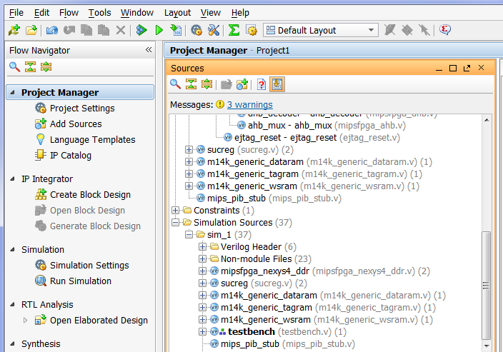
Figure 54. testbench as top-level module for simulation

Modify testbench.v to instantiate your modified MIPSfpga system (mipsfpga_sys).
If you added a memory initialization file for simulation in Lab 1, remove it by expanding Simulation Sources → sim_1 → Text and deleting any existing files (i.e., ram_reset_init.txt) as shown in Figure 55. Right-click on ram_reset_init.txt and select Remove File from Project and click OK.

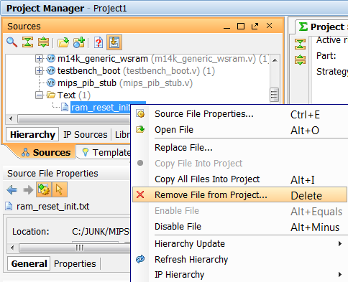
Figure 55. Remove existing memory definition file

Now add the ram_reset_init.txt file that you just created (located in MIPSfpga_Fundamentals\Xilinx\Module05_7seg\) as a simulation source. Refer to Lab 1 if you've forgotten how to do this.
Run the simulation and check that the MIPSfpga system outputs the correct values for the 7-segment display signals (IO_7SEGEN_N and IO_7SEG_N). If they don't, debug your modules. To debug, you'll likely want to view signals from lower levels in the hierarchy. Again, refer to Lab 1 instructions if you've forgotten how to do this.

As you're simulating, remember that the timing of displaying each of the 7-segment display digits is much slower than the rest of the system (~2 ms versus 20 ns cycle time).

Running the Example Assembly Program on the MIPSfpga System
Now that you have simulated and tested your added hardware to support writing values to the 7-segment displays, you are ready to run your MIPS assembly program on the MIPSfpga system in hardware.
Open a command shell and change to the following directory:
MIPSfgpa_Fundamentals\Scripts\Nexys4_DDR
At the prompt, type:
loadMIPSfpga.bat C:\MIPSfpga_Fundamentals\Xilinx\Lab05_7seg\AssemblyExample
Make sure that your MIPS assembly program operates correctly in hardware. If not, you get another chance to practice your debugging skills.

Example C Program on the MIPSfpga Core
Now write a simple C program that writes to the 7-segment displays. Compile and debug your program and then run and test your C program in hardware.

Write a Program Using 7-segment Displays
Now you will write two new C programs to exercise the 7-segment display capabilities:
- The first program, called SwTo7segHex, should write the hexadecimal value of the 16 switches to the 7-segment displays.
- The second program, called SwTo7segDec, should write the decimal value of the 16 switches to the 7-segment displays.
When you are done, run, debug, and test your programs on your modified MIPSfpga system.

Lab 9
Porting MIPSfpga to Other FPGA Boards

MIPSfpga Lab 9: Porting MIPSfpga to Other FPGA Boards

Introduction
This lab describes how to port the MIPSfpga system onto other FPGA boards. You may choose to use a board other than the Nexys4 DDR board because of, for example, wanting a lower-cost option or having existing availability of other boards.

We will describe how to port the MIPSfpga system to Digilent's Basys3 board and Digilent's Nexys4 board, which is the predecessor to the Nexys4 DDR board. You may follow similar steps to port the MIPSfpga system to other boards based on Xilinx FPGAs. Table 7 gives an overview of the features of the Nexys4 and Basys3 FPGA boards, as well as the Nexys4 DDR board that we've been using in the prior labs. If desired, the prior labs could have been completed on either the Nexys4 or Basys3 FPGA boards – or on other FPGA boards as well.

Table 7. FPGA Boards
Board | Overall specifications | Web Link | Cost
Nexys4 DDR | - FPGA: Artix-7 (XC7A100T-CSG324)  - Amount of block RAM: 607 KB  - # of Logic Cells: 101k  - 7-segment displays: 8  - Switches: 16  - Pushbuttons: 5  - LEDs: 16  - PMOD Connectors: 5 | http://www.digilentinc.com/Products/Detail.cfm?Prod=NEXYS4DDR | $159 (academic),  $320 (non-academic)
Nexys4 | Similar to Nexys4 DDR (for example, all of the above specifications are the same) | http://www.digilentinc.com/Products/Detail.cfm?Prod=NEXYS4 | $179 (academic),  $320 (non-academic)
Basys3 | - FPGA: Artix-7 (XC7A35T-CPG236)  - Amount of block RAM: 225 KB  - # of Logic Cells: 33k  - 7-segment displays: 4  - Switches: 16  - Pushbuttons: 5  - LEDs: 16  - PMOD Connectors: 4 | http://www.digilentinc.com/Products/Detail.cfm?Prod=BASYS3 | $79 (academic),  $149 (non-academic)

Porting MIPSfpga to Digilent's Basys3 Board
In this section we show you how to port the MIPSfpga system onto Digilent's Basys3 board, shown in Figure 56.

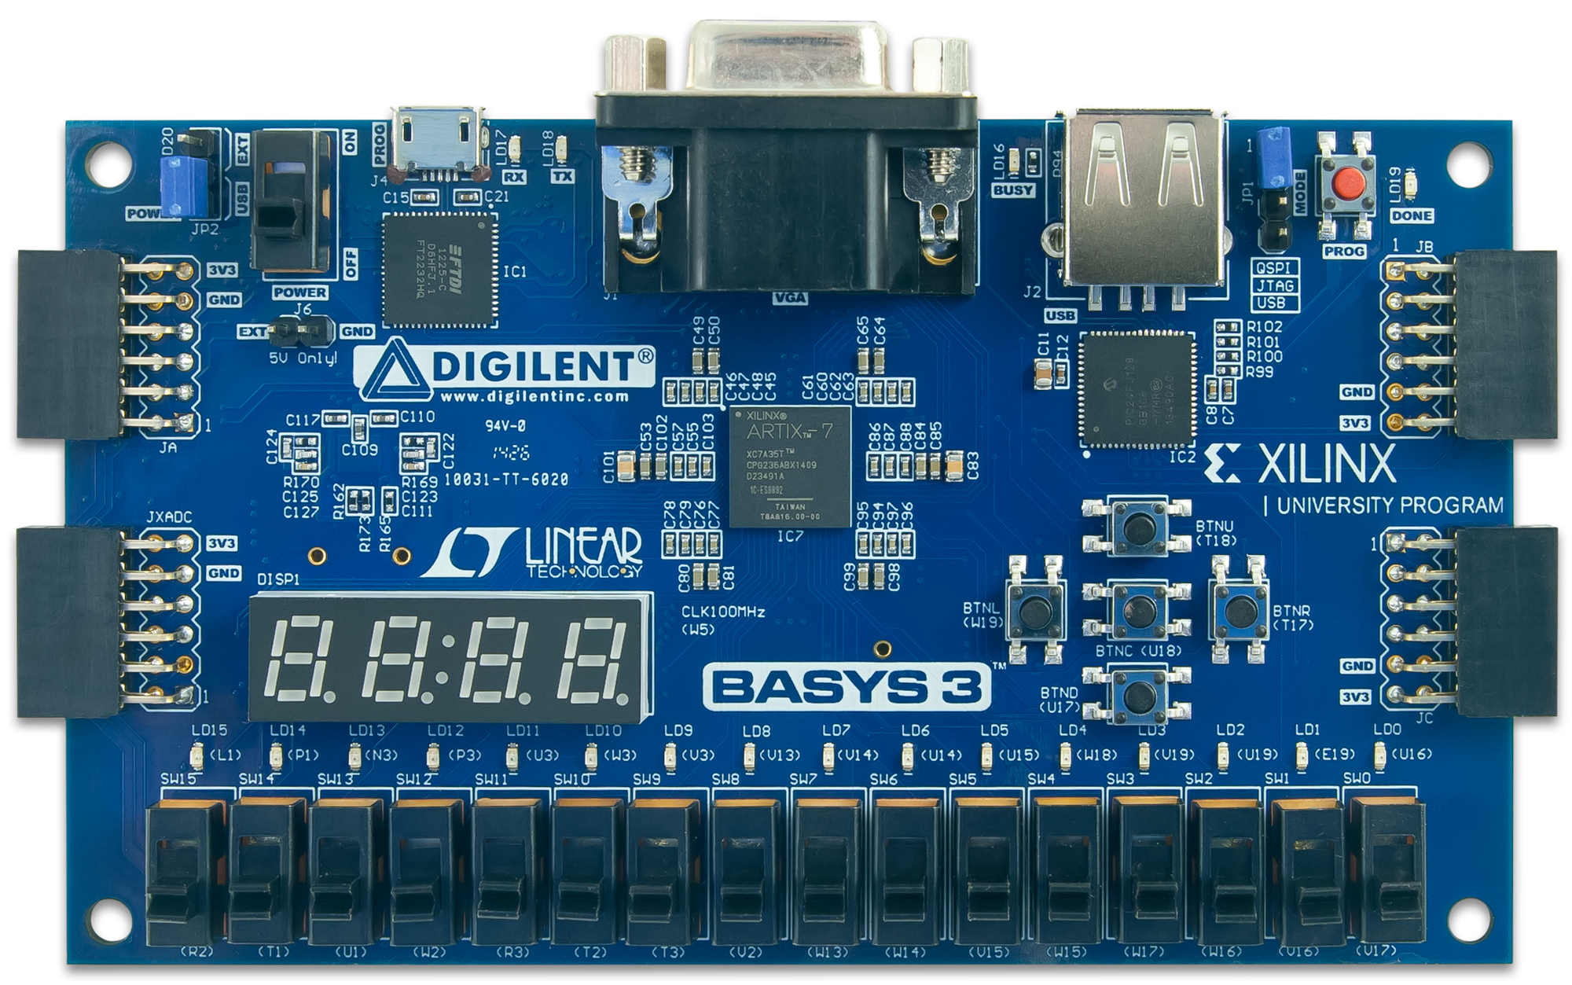
Figure 56. Digilent's Basys3 Board

As listed in Table 7, the Basys3, like the Nexys4 DDR board, is also built around Xilinx's Artix7 FPGA, however it is a smaller version of the FPGA on the Nexys4 DDR board. The Basys3's Artix7 FPGA has about a third of the logic and memory as the one on the Nexys4 DDR board (225 KB of block RAM and 33K configurable logic blocks (CLBs) on the Basys3 vs. 607 KB of block RAM and 101K CLBs on the Nexys4 DDR). The MIPSfpga hardware fits easily on either board, however, the amount of block RAM needs to be reduced in order to fit on the Basys3 board.

MIPSfpga Modifications for the Basys3 Board
To port the MIPSfpga system to the Basys3 board, we must:
Step 1. Write a wrapper module that maps the MIPSfpga I/O to the Basys3 board I/O
Step 2. Decrease the memory size of the MIPSfpga system to fit on the Basys3 board
Step 3. Add a constraints file that maps the board I/O to the correct FPGA pins

We describe each of these steps in detail and then show how to download the MIPSfpga system onto the Basys3 board. We also describe how to build a Vivado project and compile the MIPSfpga system for the Basys3 board.

Step 1. Basys3 Wrapper Module
First, we write a wrapper module that maps the MIPSfpga I/O to the I/O on the Basys3 board. Browse to the MIPSfpga_Fundamentals\Xilinx\Lab09_PortingMIPSfpga\Basys3 folder and open the mipsfpga_basys3.v file.

First, observe the mipsfpga_basys3 module inputs and outputs. These signals are the interfaces to the Basys3 board.

module mipsfpga_basys3( input clk,
input btnU, btnD, btnL, btnR, btnC,
input [15:0] sw,
output [15:0] led,
inout [ 5:0] JB
);

clk is the onboard 100 MHz clock. btnU, btnD, btnL, btnR, and btnC are the names of the up, down, left, right, and center push buttons on the Basys3 board. We use btnC to reset the processor.

Input signal sw[15:0] are the 16 switches, led[15:0] are the 16 LEDs, and so on. The JB signals are the PMODB connector pins that connect to the EJTAG signals needed by the Bus Blaster. Notice that the JB connector is on the upper right of the Basys3 board (see Figure 56) and on the lower right of the Nexys4 DDR board.

Next, the phase-lock-loop, clk_wiz_0, is instantiated to create the 50 MHz MIPSfpga system clock from the onboard 100 MHz clock.

clk_wiz_0 clk_wiz_0(.clk_in1(clk), .clk_out1(clk_out));

The following lines manually connect the tck pin (JB[3]) to an input buffer (IBUF) and then to a clock buffer (BUFG) to address the problem that the JB[3] pin carries a clock signal but is not connected to a clock buffer.

IBUF IBUF1(.O(tck_in),.I(JB[3]));
BUFG BUFG1(.O(tck), .I(tck_in));

Finally, the heart of the module is to instantiate the MIPSfpga system (mipsfpga_sys) and connect it to the Basys3 I/O.

mipsfpga_sys mipsfpga_sys(
.SI_Reset_N(~btnC),
.SI_ClkIn(clk_out),
.HADDR(),
.HRDATA(),
.HWDATA(),
.HWRITE(),
.EJ_TRST_N_probe(JB[4]),
.EJ_TDI(JB[1]),
.EJ_TDO(JB[2]),
.EJ_TMS(JB[0]),
.EJ_TCK(tck),
.SI_ColdReset_N(JB[5]),
.EJ_DINT(1'b0),
.IO_Switch({2'b0,sw}),
.IO_PB({btnU, btnD, btnL, 1'b0, btnR}),
.IO_LEDR(led),
.IO_LEDG()
);

Step 2. Decrease Memory
The Basys3 board only has 225 KB of block RAM instead of the 607 KB of the Nexys4 DDR board. Thus, the two memory blocks (128 KB for boot RAM and 256 KB for program RAM) will not fit on the Basys3 board. Luckily, the boot code can fit in 32 KB and we can limit our program needs to 64 KB. Thus, the total memory need (32 KB + 64 KB = 96 KB) fits on the Basys3 board. The remaining 225-96 = 129 KB of block RAM can used for other memory needs of the MIPSfpga system, such as caches.

We reduce the amount of memory by modifying the memory sizes declared in the Verilog header file. Again, browse to the MIPSfpga_Fundamentals\Xilinx\Lab09_PortingMIPSfpga\Basys3 directory and open the mipsfpga_ahb_const.vh file. The size of the reset (boot) RAM address is 13 bits. So the boot RAM has 2¹³ 32-bit words = 2¹⁵ bytes = 32 KB.

`define H_RAM_RESET_ADDR_WIDTH (13)

The size of the program RAM address is 14 bits. So the program RAM has 2¹⁴ 32-bit words = 2¹⁶ bytes = 64 KB.

`define H_RAM_ADDR_WIDTH (14)

Step 3. Basys3 Constraints File
As the last step, we add a constraints file that maps the wrapper module's (mipsfpga_basys3) I/O signal names to the correct FPGA pins on the Basys3 FPGA board. Again, browse to the MIPSfpga_Fundamentals\Xilinx\Lab09_PortingMIPSfpga\Basys3 directory and open the mipsfpga_basys3.xdc Xilinx Design Constraints file. This file maps the FPGA pins to the inputs and outputs of the mipsfpga_basys3 wrapper module. For example, the following line maps the input clk to FPGA package pin W5, which is fed by the 100 MHz clock (period = 10 ns) on the Basys3 board.

set_property PACKAGE_PIN W5 [get_ports clk]
set_property IOSTANDARD LVCMOS33 [get_ports clk]
create_clock -add -name sys_clk_pin -period 10.00 -waveform {0 5} [get_ports clk]

The following line addresses the issue that the tck pin of the EJTAG interface is not connected to an FPGA pin with a clock buffer.

set_property CLOCK_DEDICATED_ROUTE FALSE [get_nets tck_in]

The lines below map the switch inputs (sw[15:0]) to the FPGA pins that are physically wired to the switches on the Basys3 board. For example sw[0] is connected to the Artix7 package pin V17, sw[1] to pin W16, and so forth. They all use LVCMOS 3.3V signal levels.

## Switches
set_property PACKAGE_PIN V17 [get_ports {sw[0]}]
set_property IOSTANDARD LVCMOS33 [get_ports {sw[0]}]
set_property PACKAGE_PIN V16 [get_ports {sw[1]}]
set_property IOSTANDARD LVCMOS33 [get_ports {sw[1]}]
set_property PACKAGE_PIN W16 [get_ports {sw[2]}]
...

The timing constraints for FPGA I/O are specified at the bottom of the file.

Loading the MIPSfpga System onto the Basys3 Board
A pre-compiled bitfile called mipsfpga_basys3.bit contains the MIPSfpga system targeted to the Basys3 board. It is provided in this directory:

MIPSfpga_Fundamentals\Xilinx\Lab09_PortingMIPSfpga\Basys3

Open Vivado and load the bitfile onto the Basys3 board. Press the center pushbutton (BTNC) on the Basys3 board to reset the processor. You should now see the LEDs display incremented values. To use Codescape and the Bus Blaster probe to program the MIPSfpga core, connect the Bus Blaster probe to the PMOD B connector at the top right of the board (labeled JB). Follow the same instructions as provided in previous labs (see Lab 2, for example) to download and debug programs on the MIPSfpga system running on the Basys3 board.

Setting up a Vivado Project for MIPSfpga on the Basys3 Board
Use similar steps to those described in Lab 1 to set up a Vivado project targeted to the Artix7 on the Basys3 board. Before setting up the project, make a copy of the MIPSfpga_Fundamentals\rtl_up directory and name the copy rtl_up_basys3. Copy the mipsfpga_basys3.v and mipsfpga_ahb_const.vh files to the rtl_up_basys3 folder.

Now open Vivado and create a new project. Add all the files in the rtl_up_basys3 folder as source files. Add mipsfpga_basys3.xdc from the MIPSfpga_Fundamentals\Xilinx\Lab09_PortingMIPSfpga\Basys3 folder as the constraints file. You will also need to add a 50 MHz PLL (see Lab 1 for instructions).The project target device for the Basys3 board is the xc7a35tcpg236-1 Artix7 FPGA. After the project is set up, compile, synthesize, and layout the design by generating a bitfile for the project as described in Lab 1.

MIPSfpga on the Nexys4 Board
Some universities or laboratories may have legacy Nexys4 boards, the predecessors to the Nexys4 DDR board. We provide the wrapper file and Xilinx Design Constraint file for the Nexys4 board for your convenience. They are located in this directory:

MIPSfpga_Fundamentals\Xilinx\Lab09_PortingMIPSfpga\Nexys4

The target Artix-7 FPGA is the same as the one on the Nexys4 DDR board: xc7a100tcsg324-1. A precompiled bitfile (mipsfpga_nexys4.bit) is also provided in that directory.

Other Xilinx FPGAs and FPGA Boards
You may follow the same methods described here to target different FPGA boards and Xilinx FPGAs. Specifically, you will need to write a wrapper module, include the board-specific Xilinx Design Constraints (.xdc) file, and possibly modify the amount of memory used by the MIPSfpga system. Some FPGAs may be too small for the MIPSfpga system to fit.

